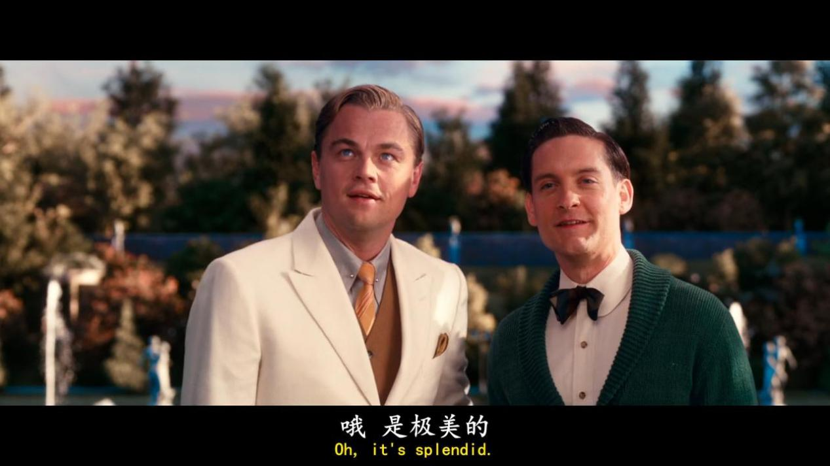

**Oh it’s splendid**

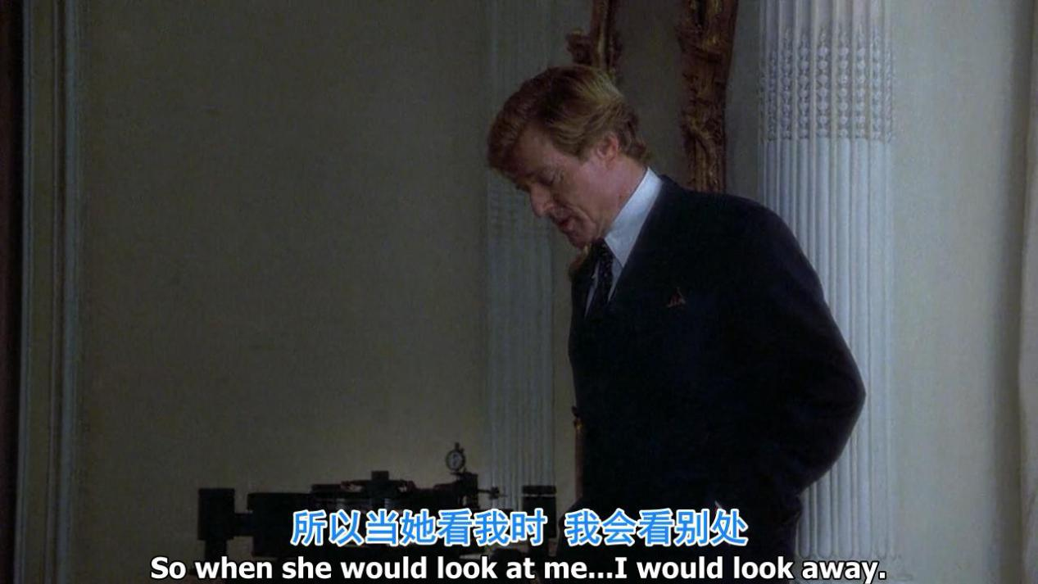

**So when she would look at me ...i would look away**

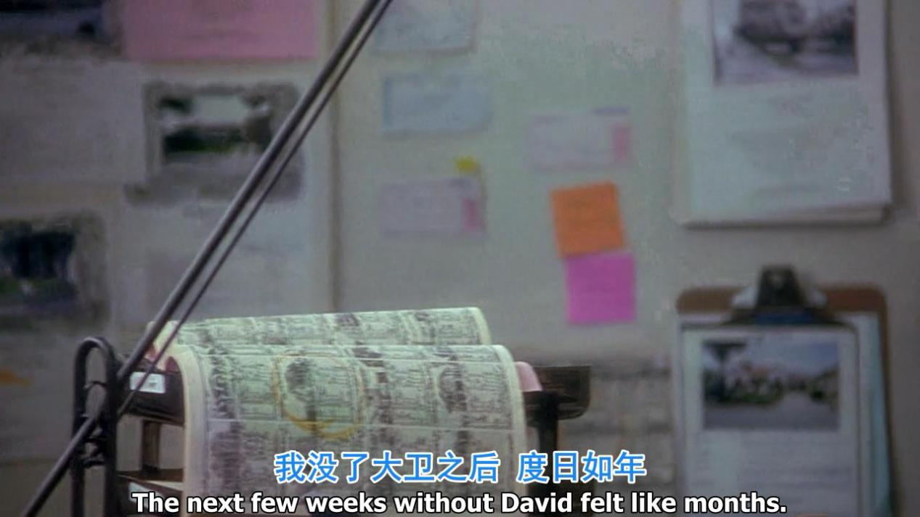

The next few weeks without you like months

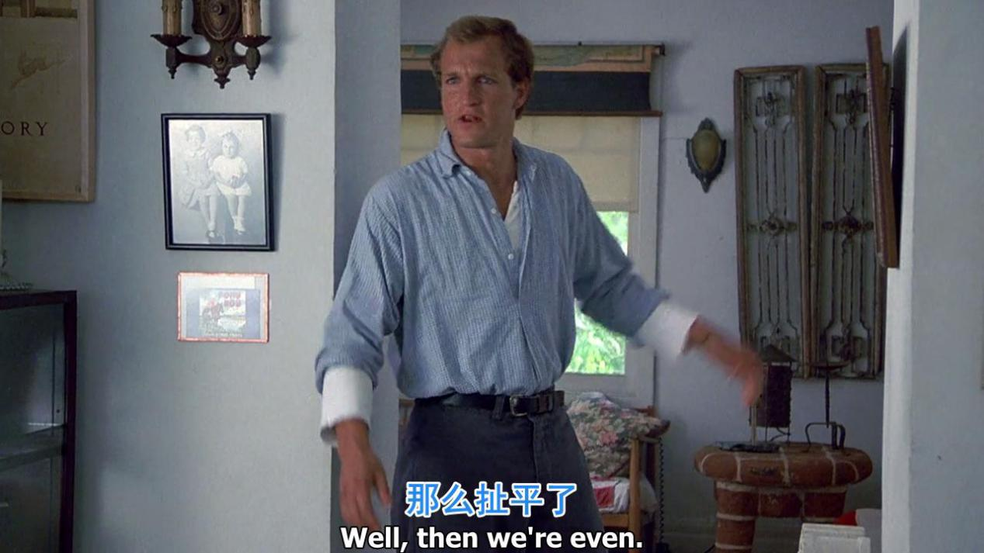

Well, then we are even

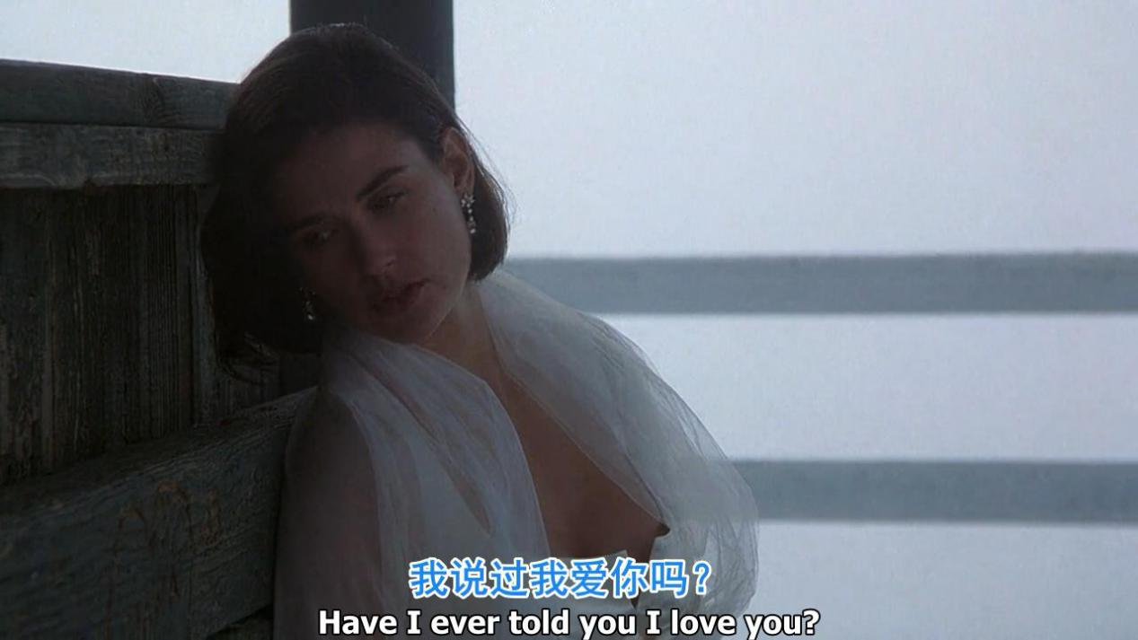

Have i ever told u i love u

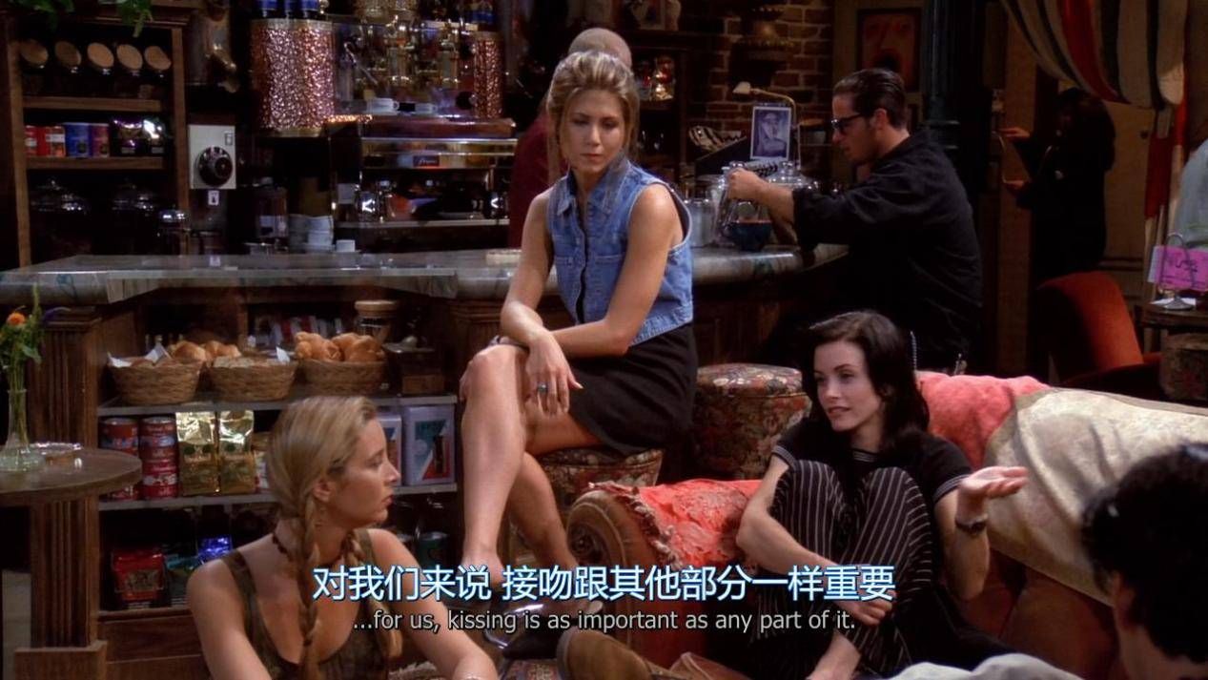

For us,kissing is as important as any part of it.

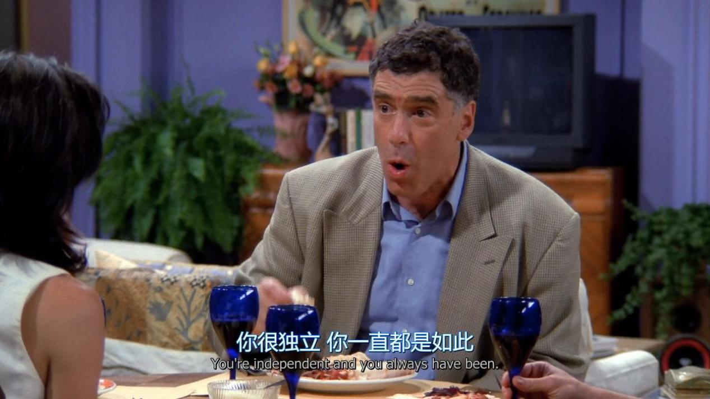

You are independent and you always have been

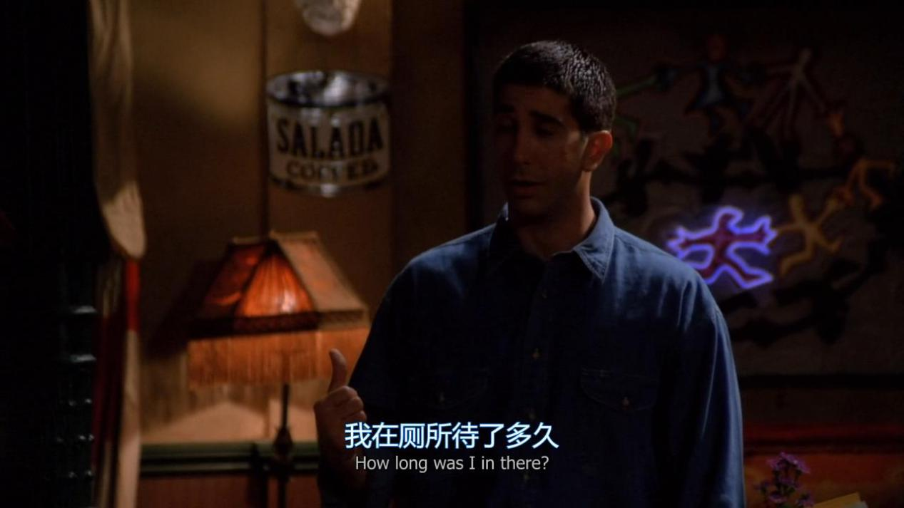

How long was i in there?

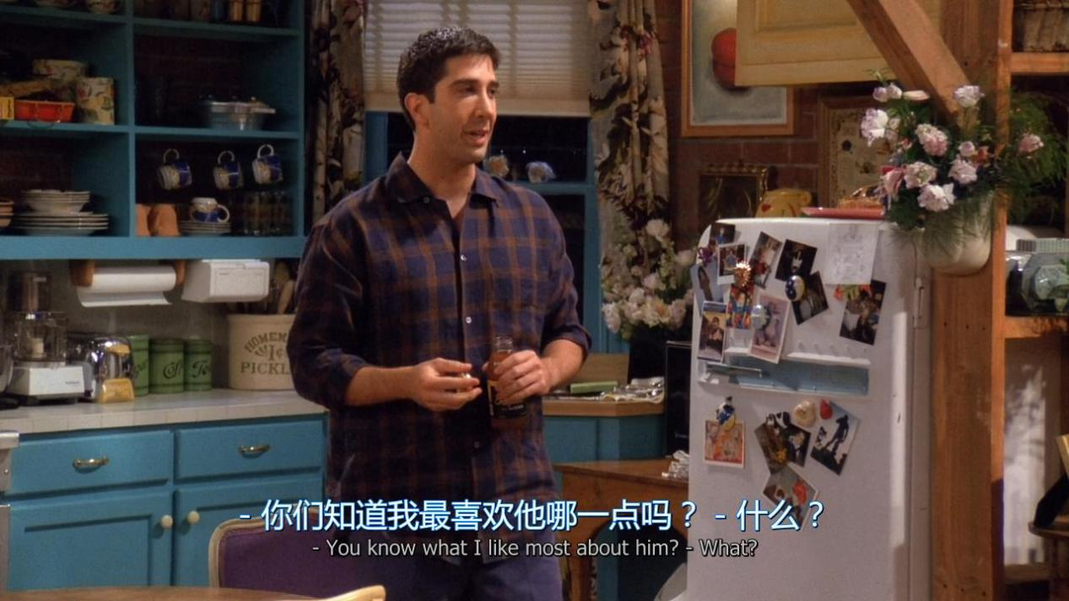

You know what i like most about him?

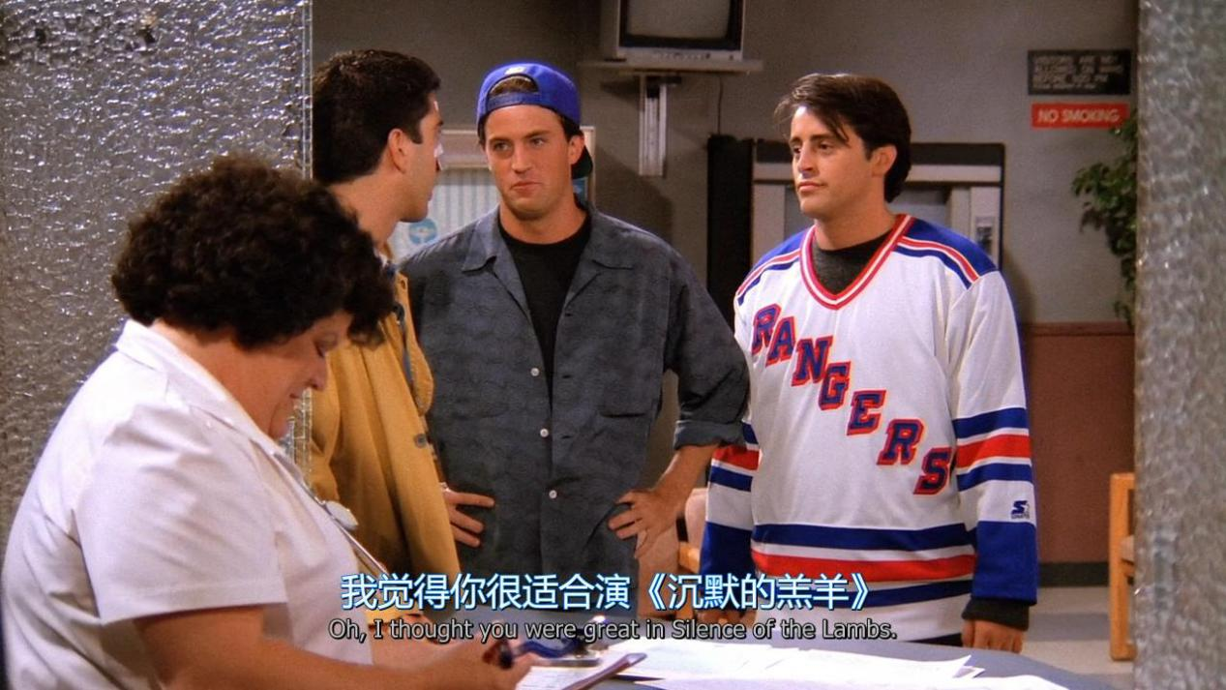

Oh,i thought you were great in Silence of the Lambs

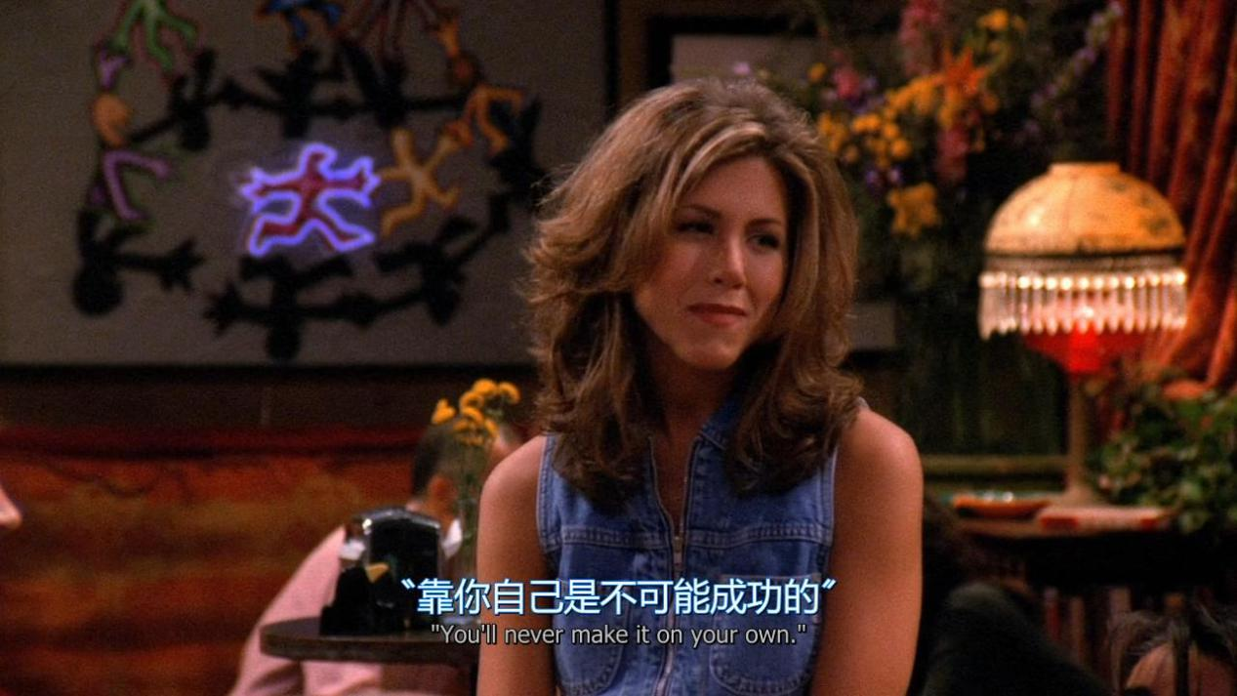

You will never make it on your own

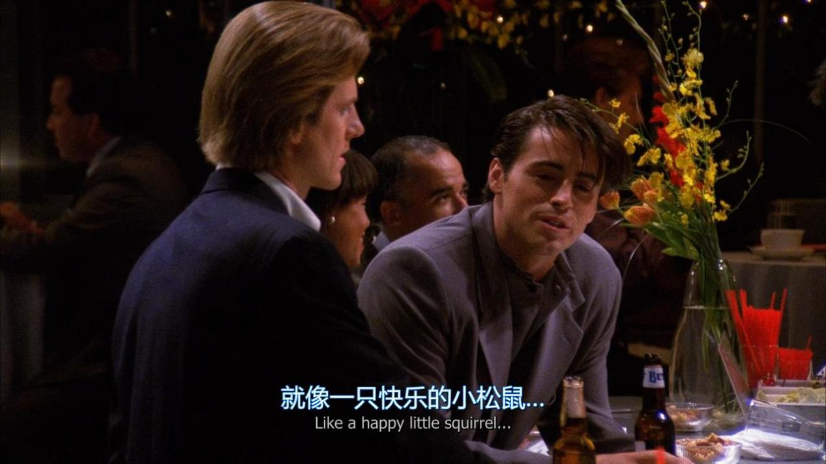

Like a happy little squirrel

1. "前肯后否"型句式  
   He is a student,isn't he?（他是一个学生,不是吗?）   
   Yes,he is.（是的,他是.） / No,he isn't.（不,他不是.）  
   She likes apples,doesn't she?（她喜欢苹果,不是吗?）  
   Yes,she does.（是的,她喜欢.） /No,she doesn't.（不,她不喜欢.）   
   二."前否后肯"型句式  
   He isn't a student,is he?（他不是一个学生,对吗?）   
   Yes,he is.（不,他是.）/ No,he isn't.（对,他不是.）   
   She doesn't like apples,does she?（她不喜欢苹果,对吗?）  
   Yes,she does.（不,她喜欢.） /No,she doesn't.isn't.（对,她不喜欢.）

I don’t give a shit 我才不在乎.（生气状态或者很屌的时候说的）

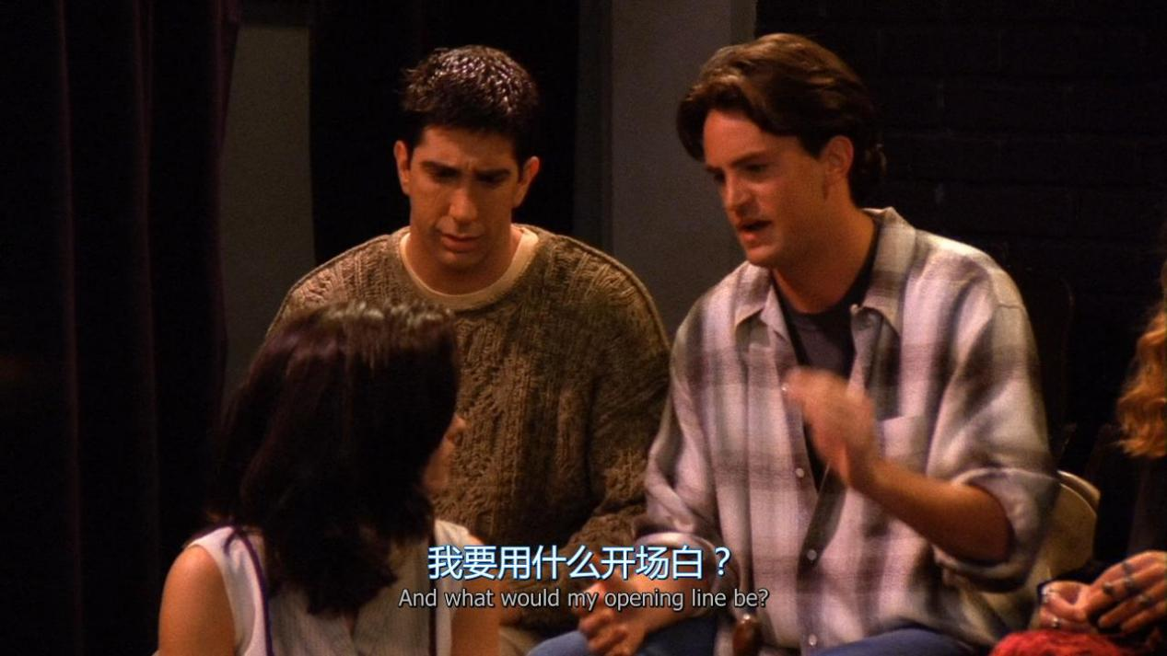

And what would my opening line be ?

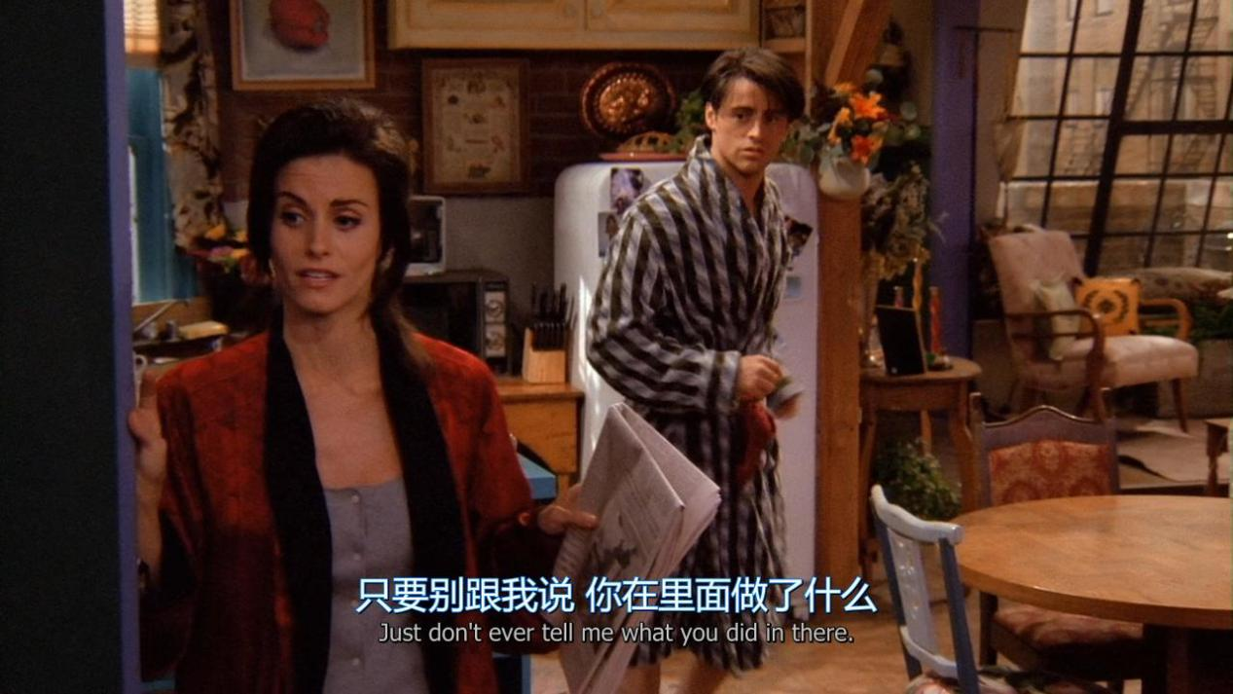

Just don’t ever tell me what you did in there

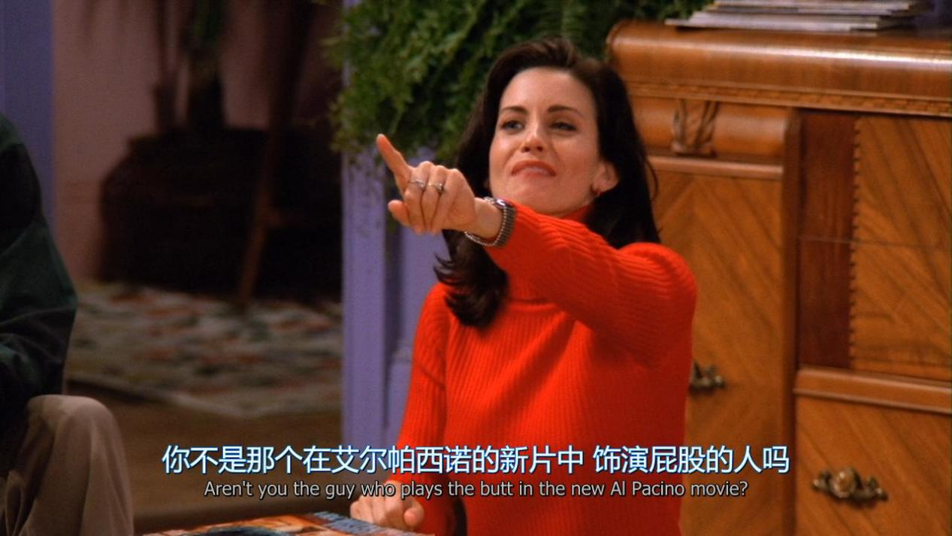

Aren’t you the guy who plays the butt in the new XX movie ?

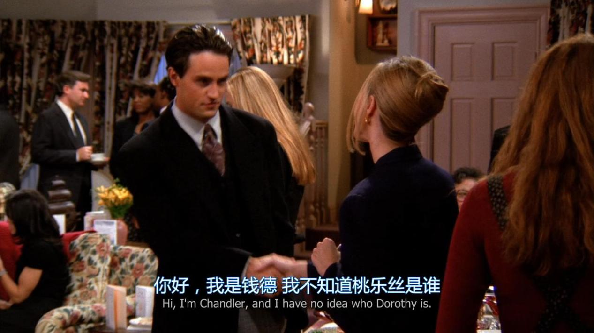

I have no idea who Ming is.

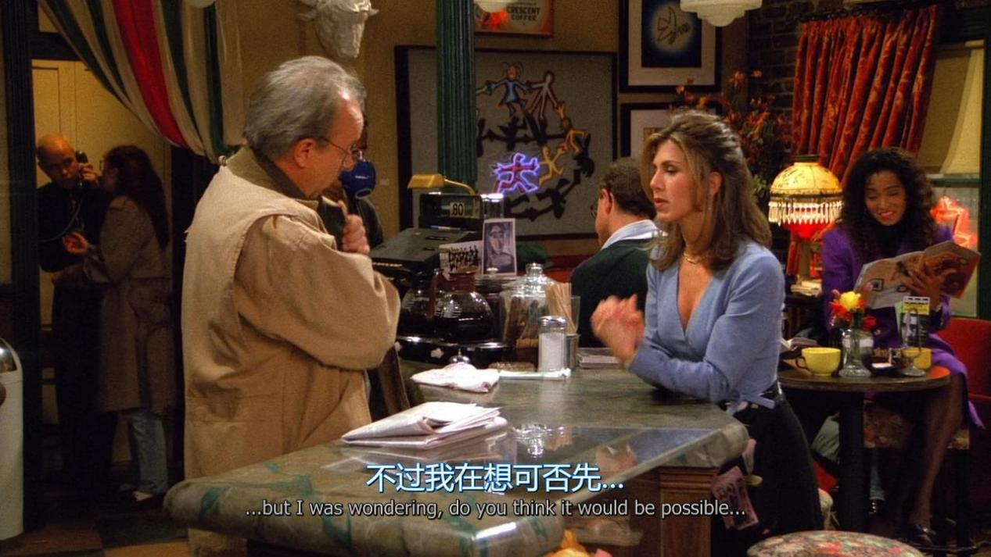

But i was wondering, do you think it would be possible

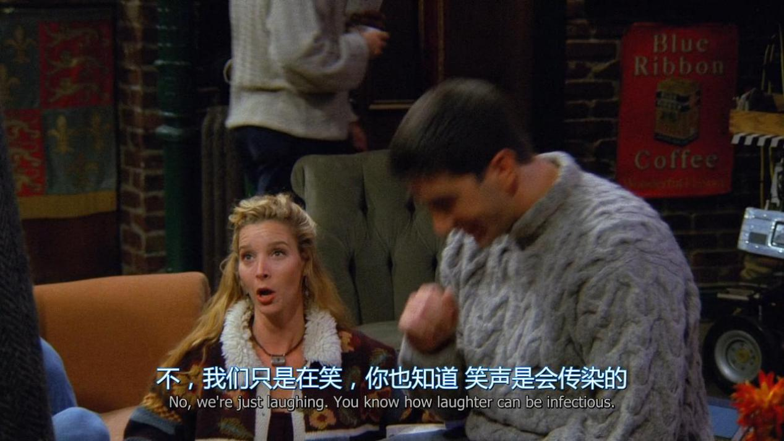

We are just laughing.you know how laughter can be infectious

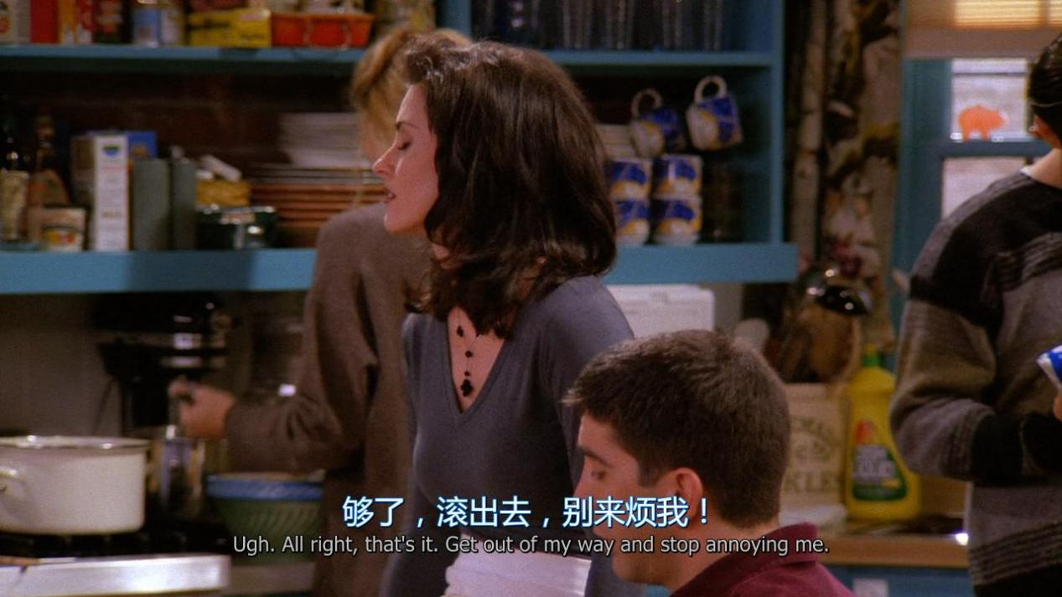

Get out of my way and stop annoying me.

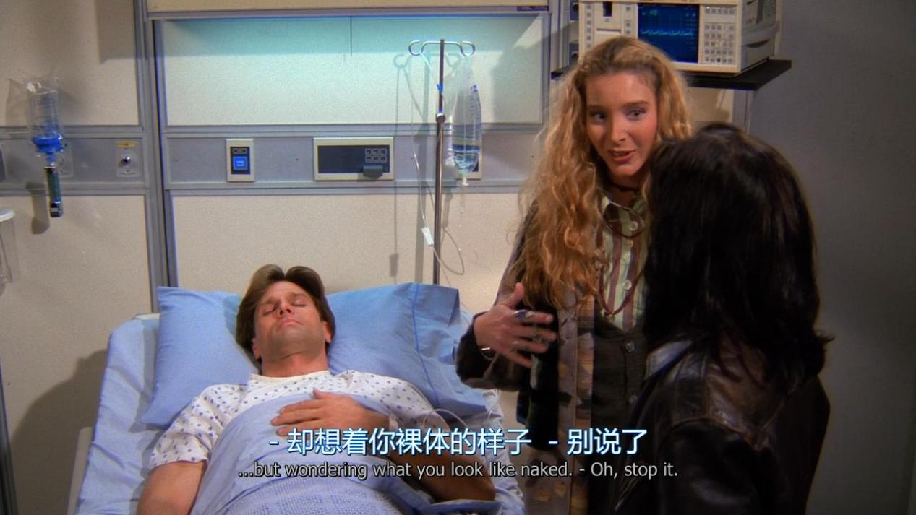

but wondering what you look like naked.

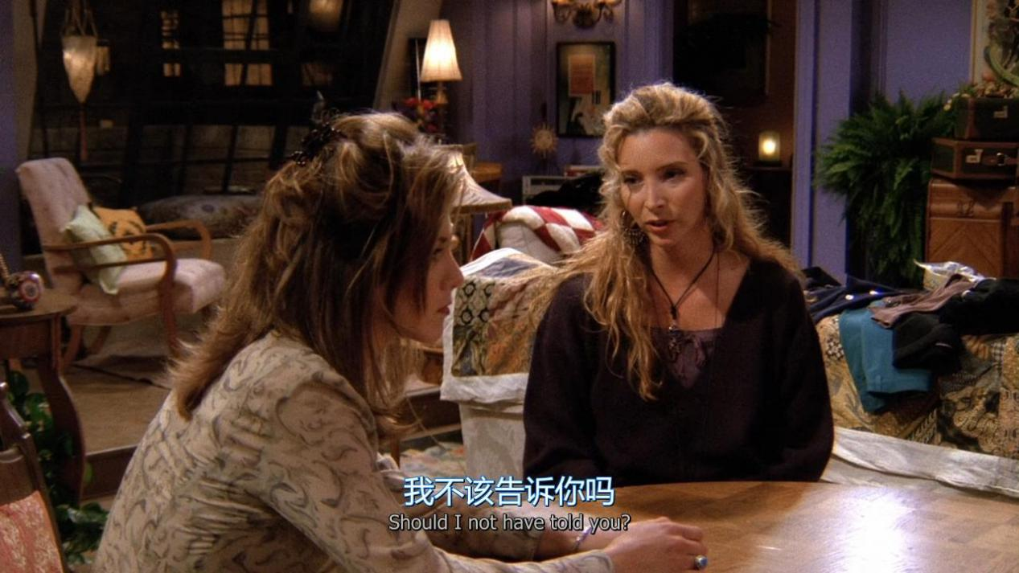

Should i not have told you ?

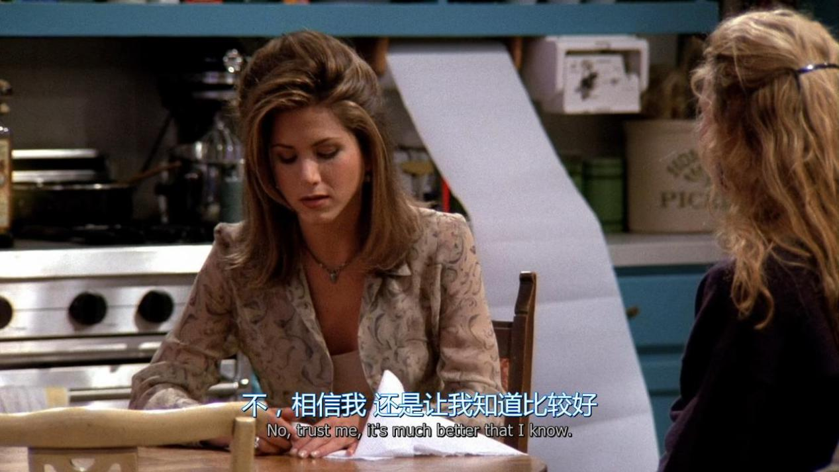

No , trust me,It’s much better that i know

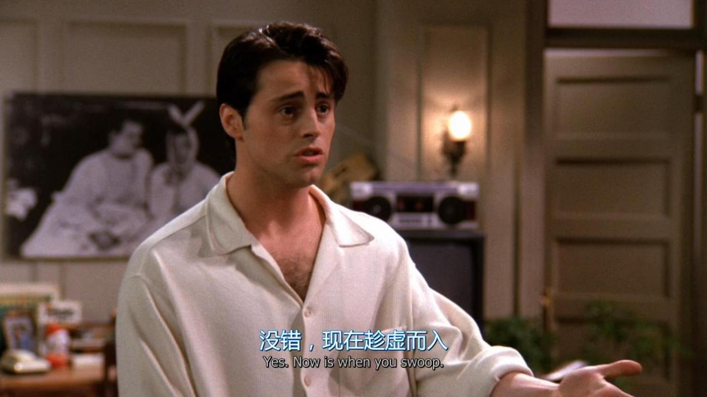

Now is when you swoop

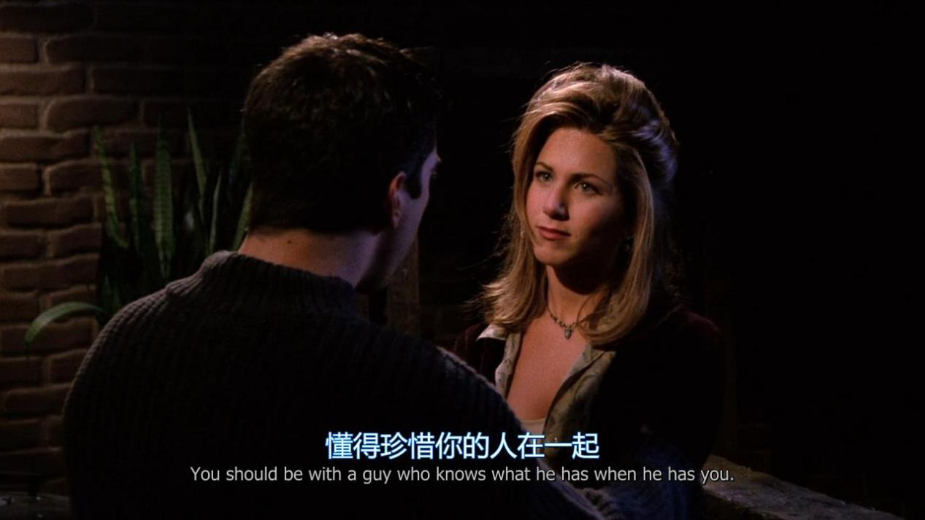

You should be with a guy who knows what he has when he has you

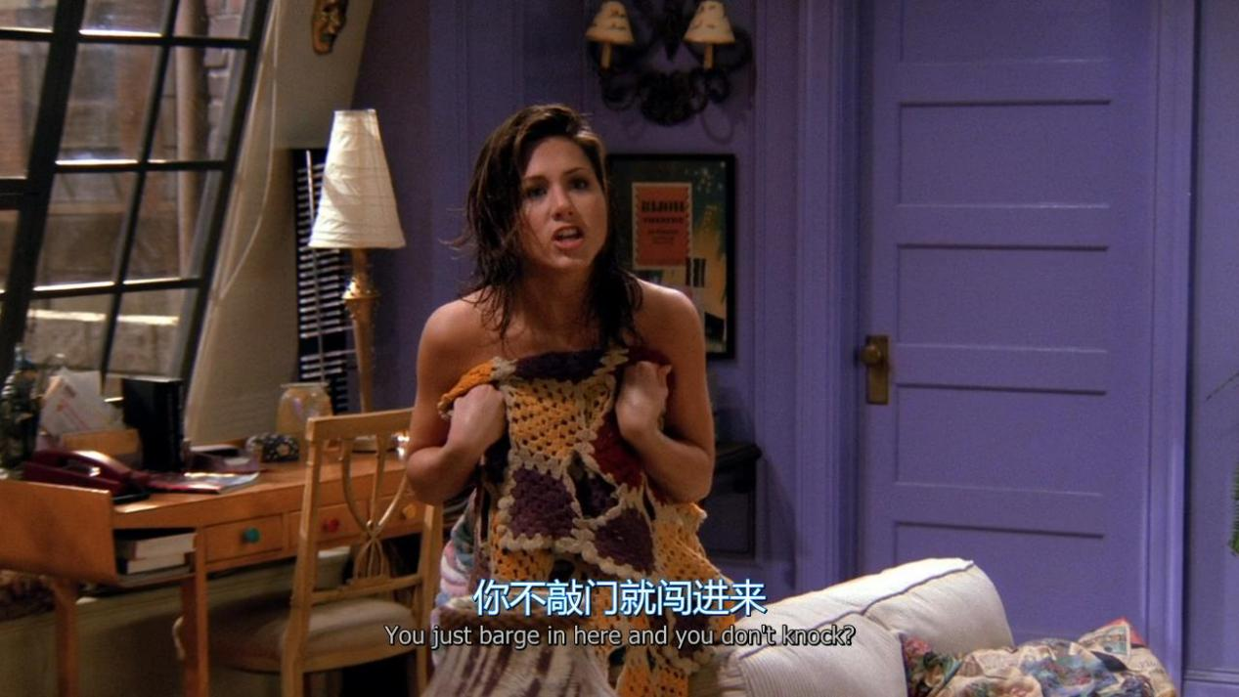

You just barge in here and you don’t knock

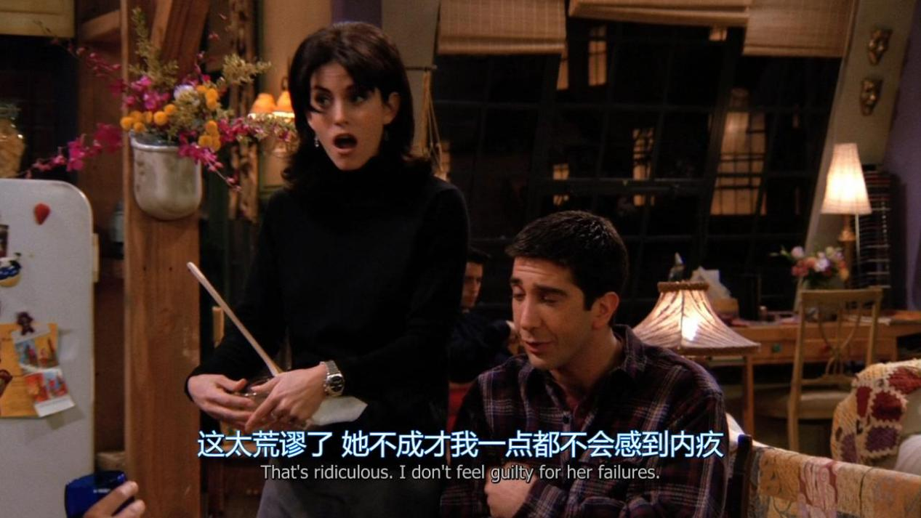

That’s ridiculous . I don’t feel guilty for her failures.

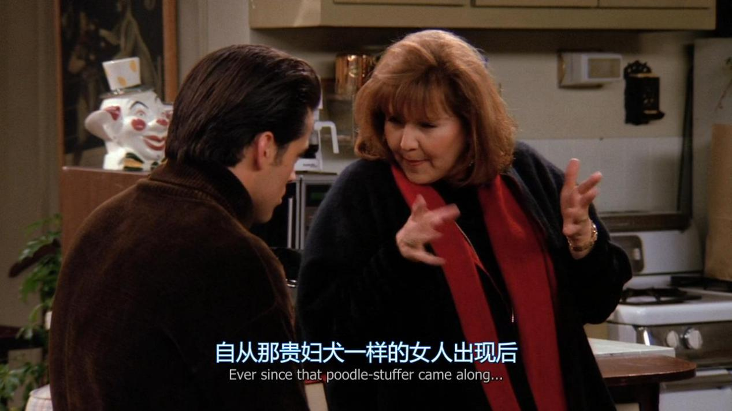

Ever since that XX came along

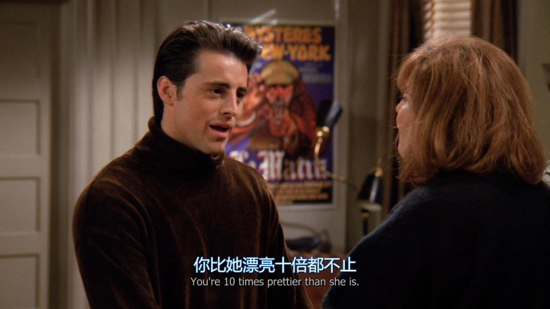

You’re 10 times prettier than she is

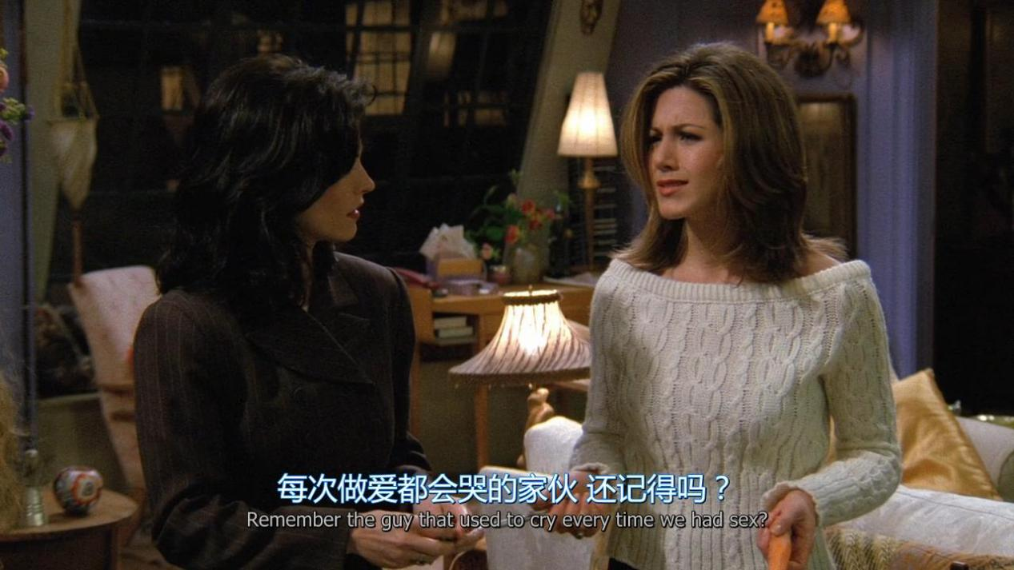

Remember the guy that used to cry every time we had sex?

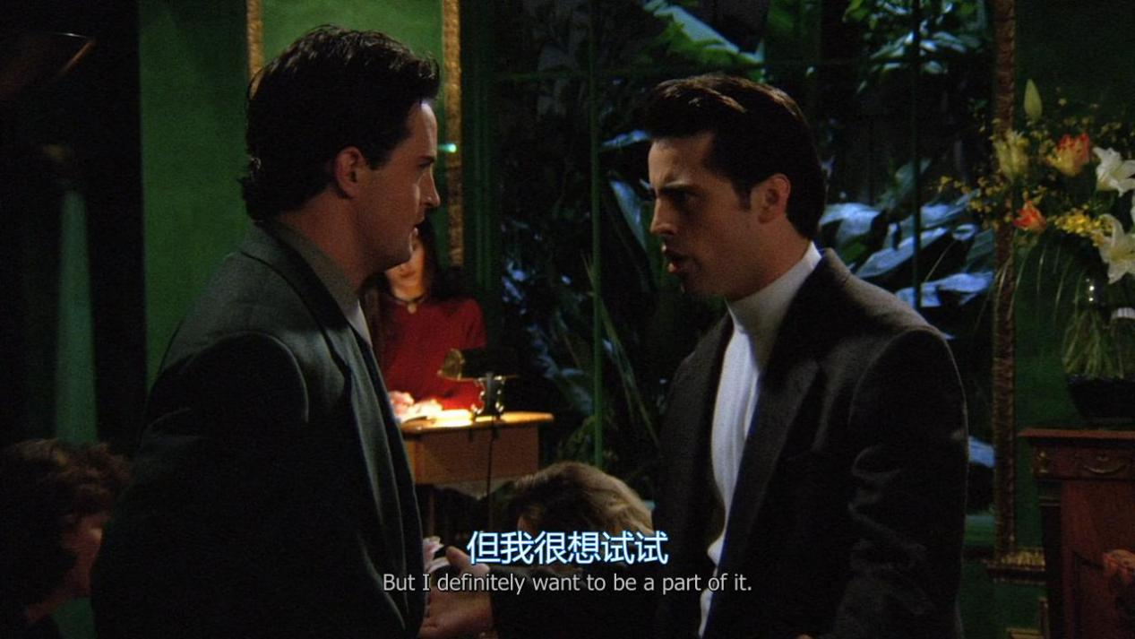

But i definitely want to be a part of it.

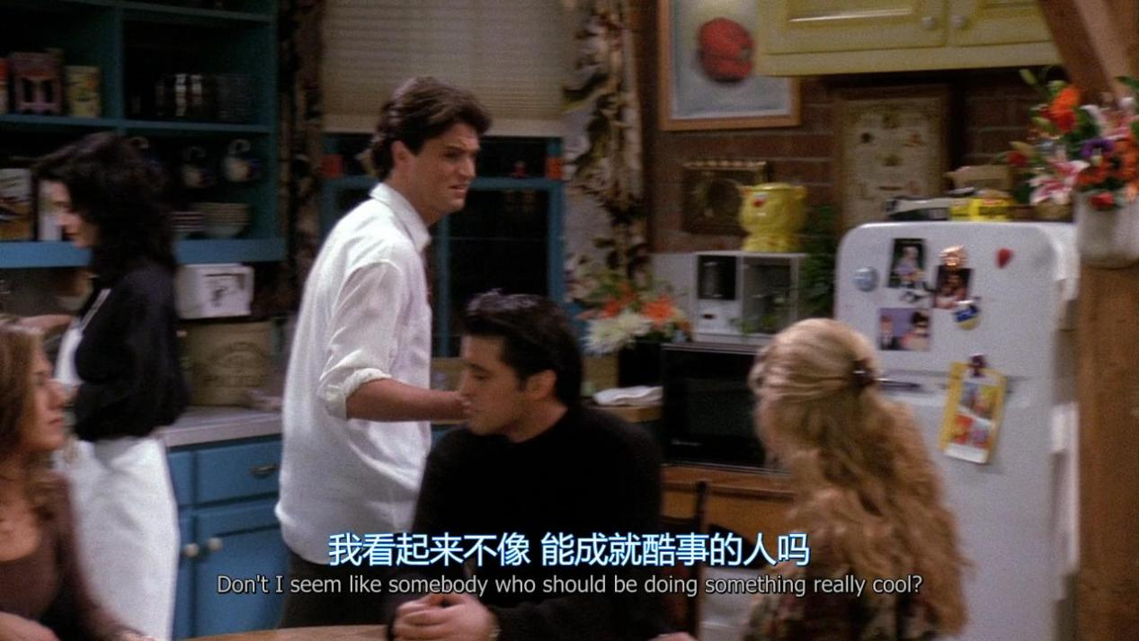

Don’t i seem like somebody who shoule be doing something really cool?

NO, you don’t(是，你不像) yes,you do(不，你是)

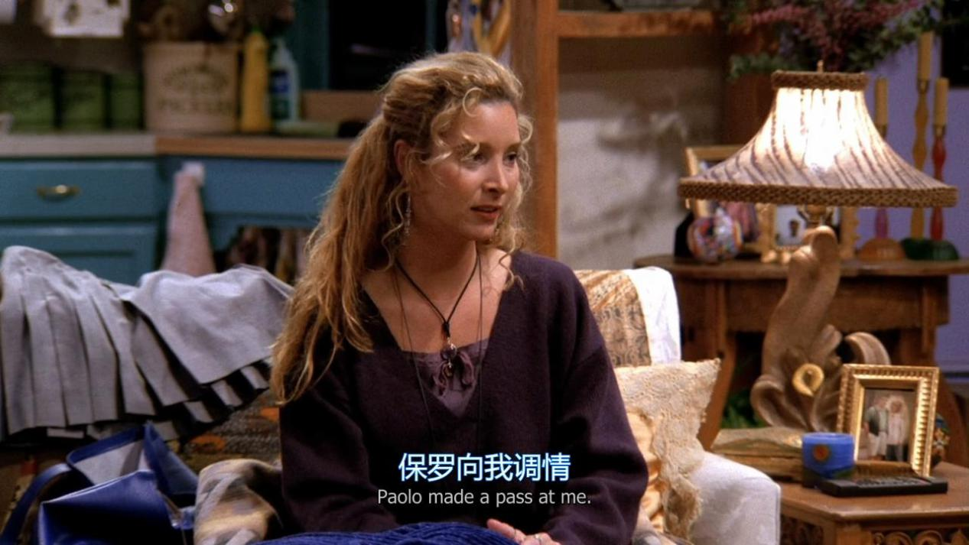

XX made a pass at me

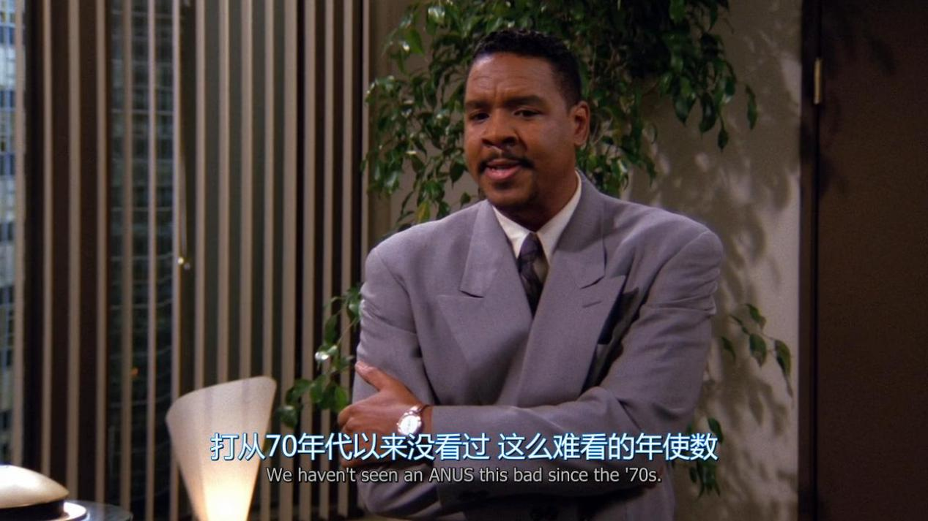

We haven’t seen an XX this bad since the ‘70s.

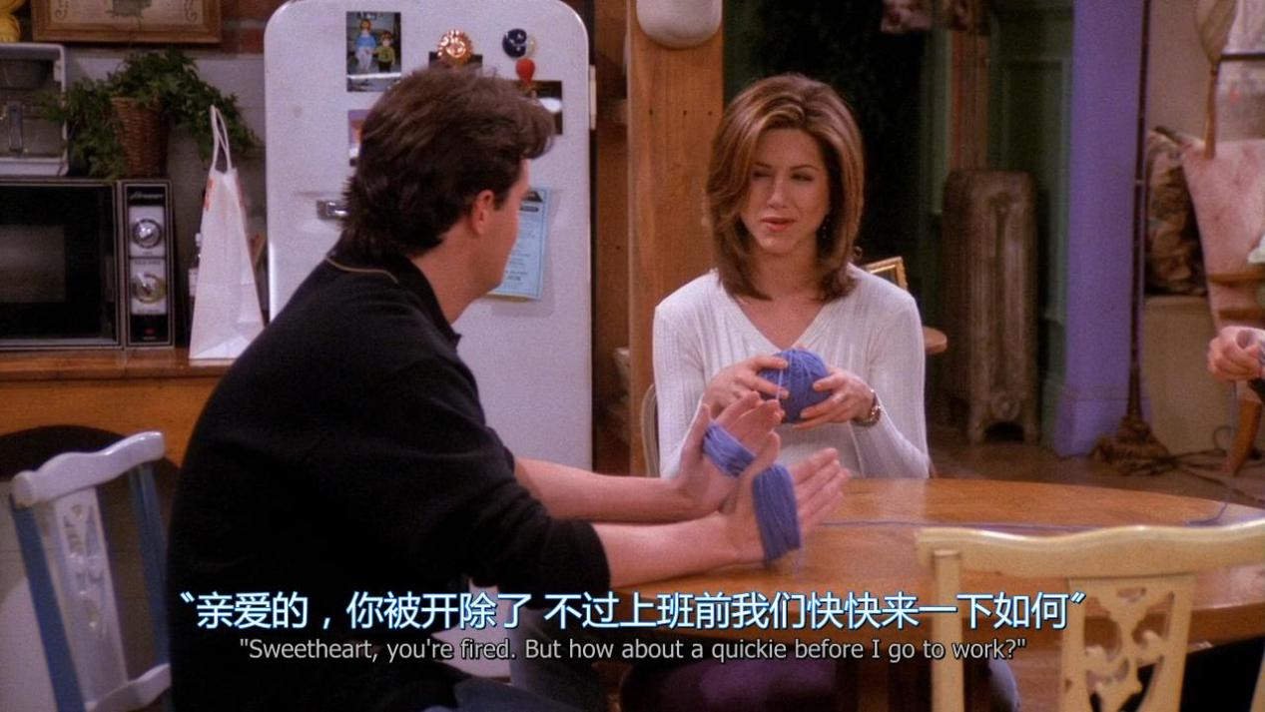

But how about a quickie before i go to work ?

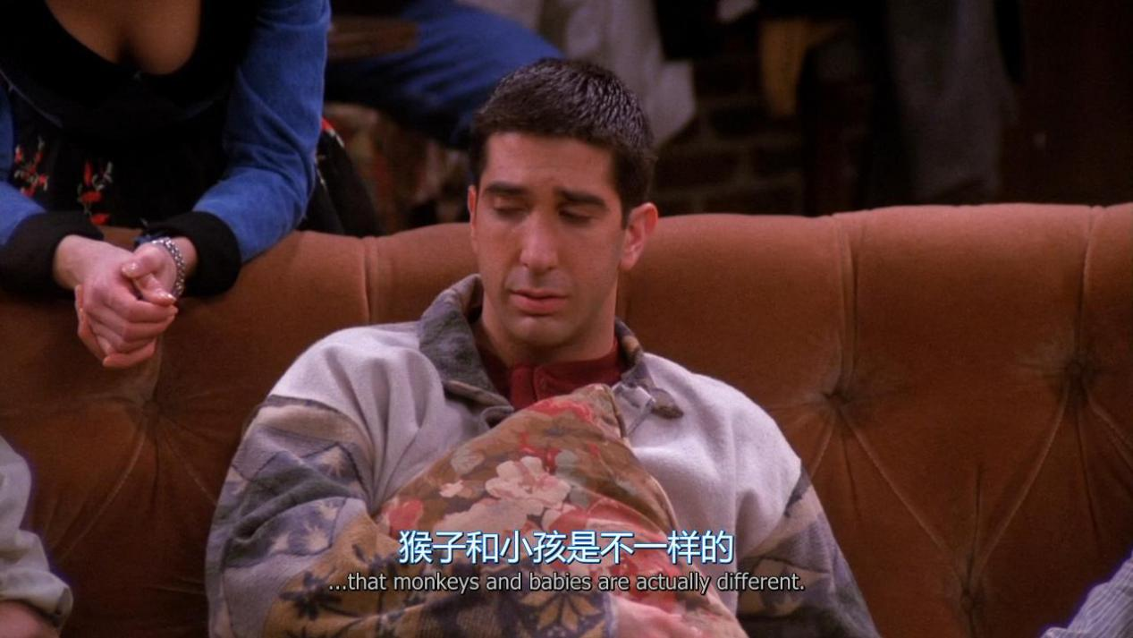

Monkeys and babies are actually different

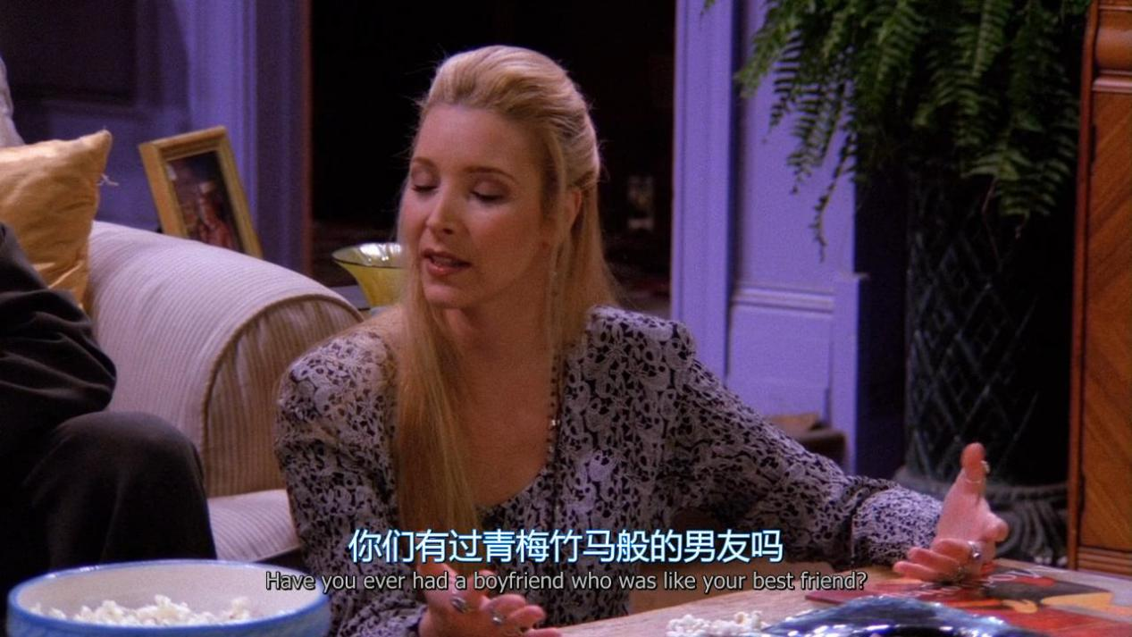

Have you ever had a boyfriend who was like your best friend ?

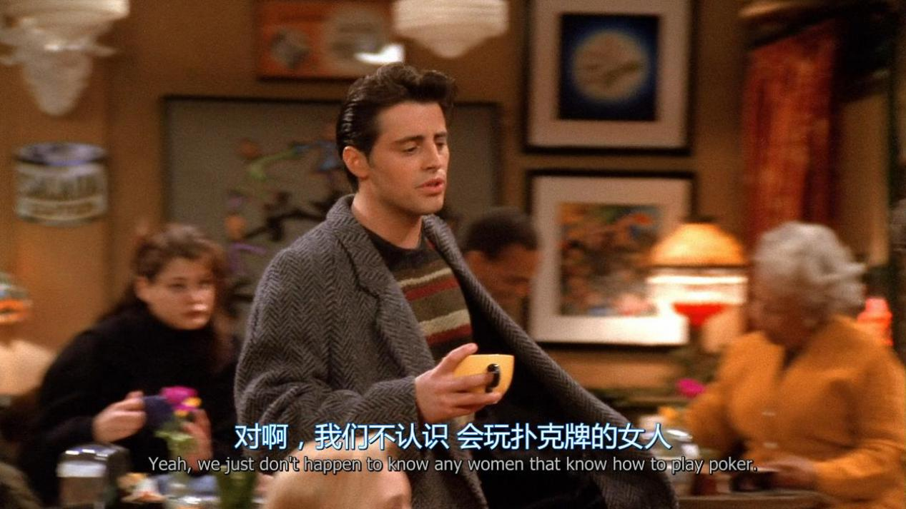

We just don’t happen to know any women that know how to play poker

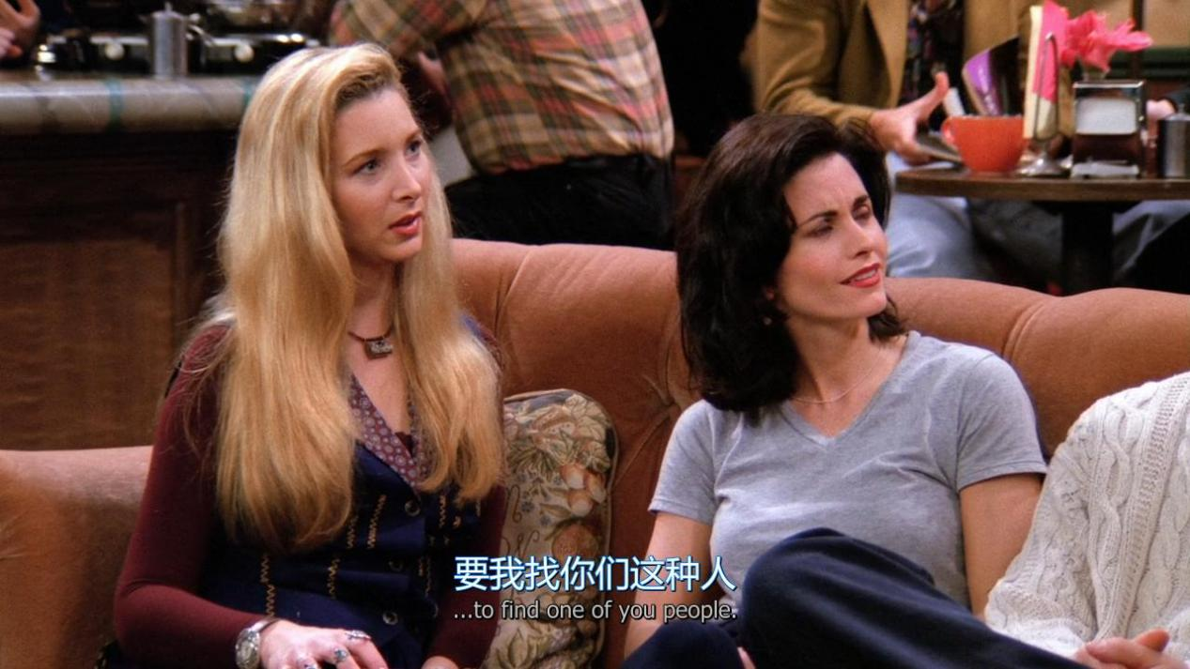

To find one of you people

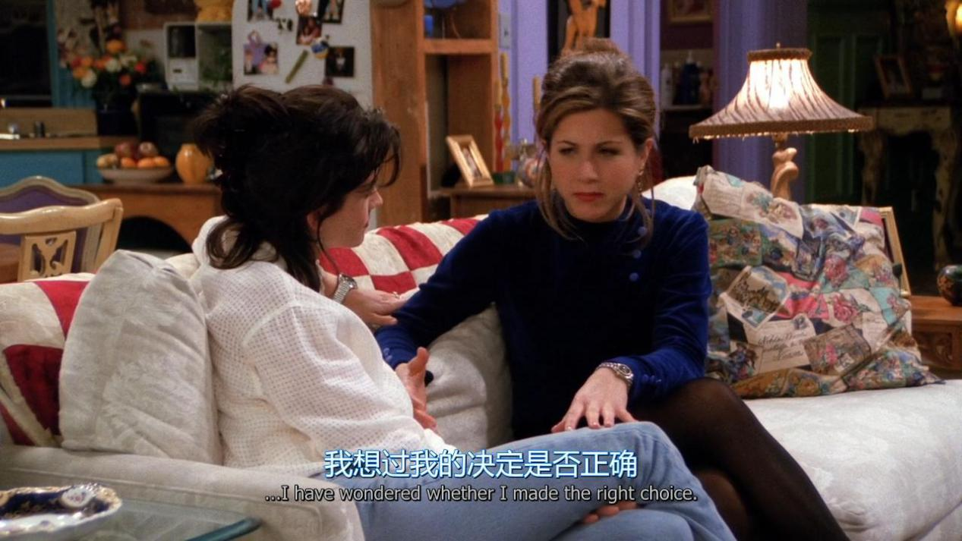

i have wondered whether i made the right choice.

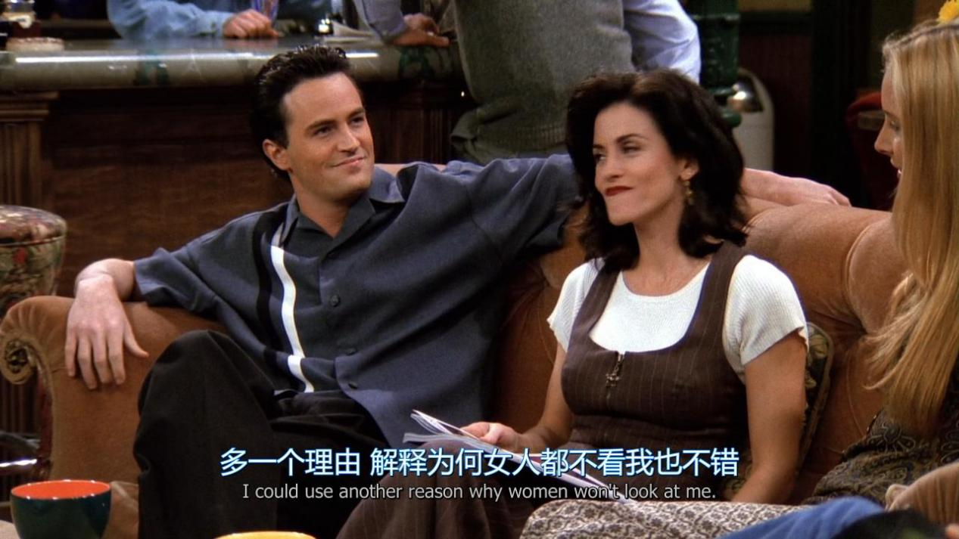

I could use another reason why women won’t look at me

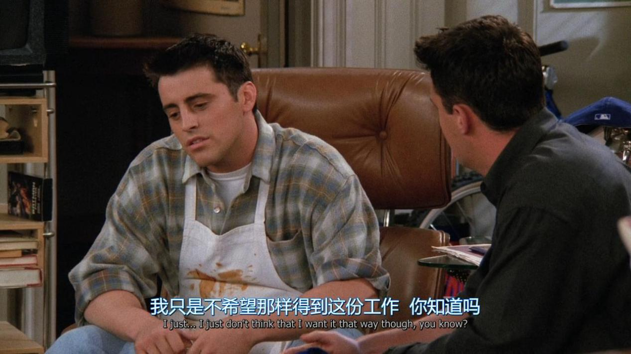

I just don’t think that i want it that way though

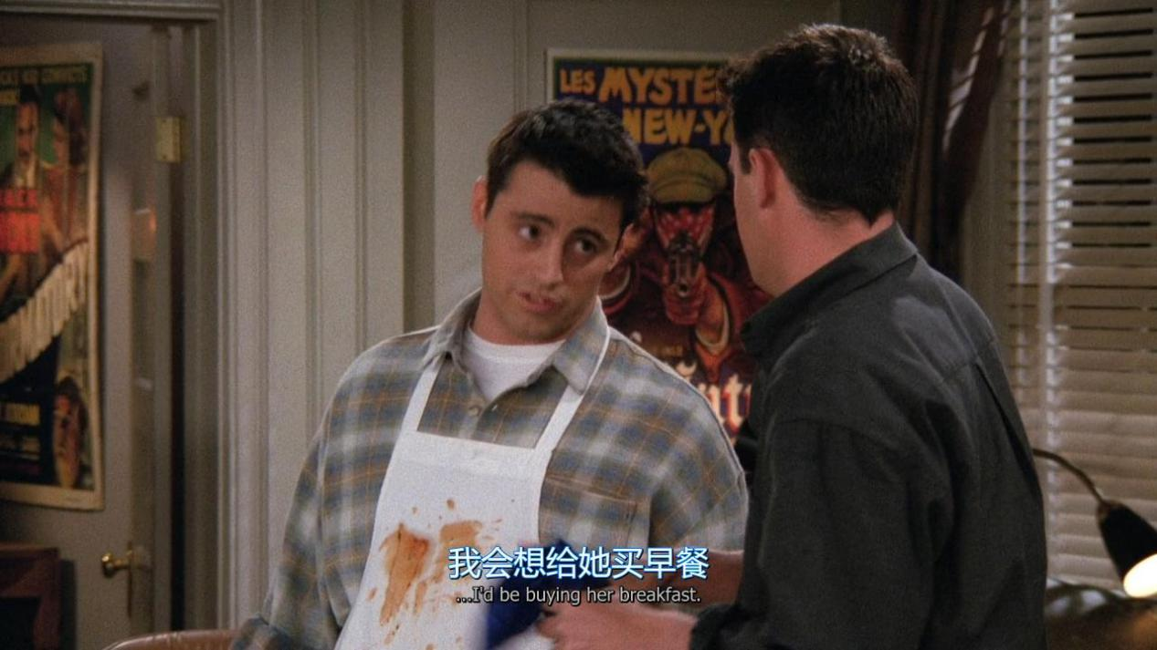

I’d be buying her breakfast

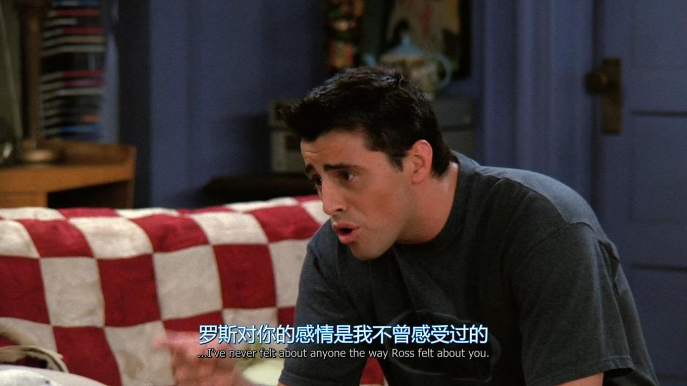

I’ve never felt about anyone the way Ross felt about you

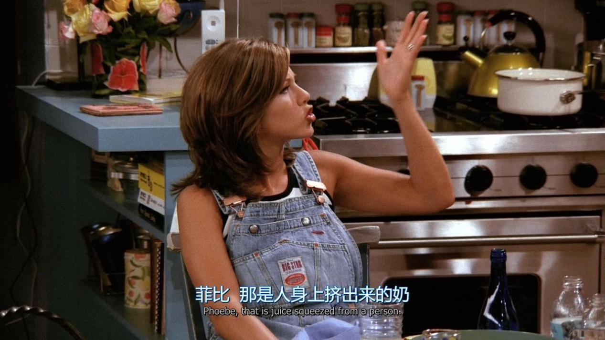

That is squeezed from a person

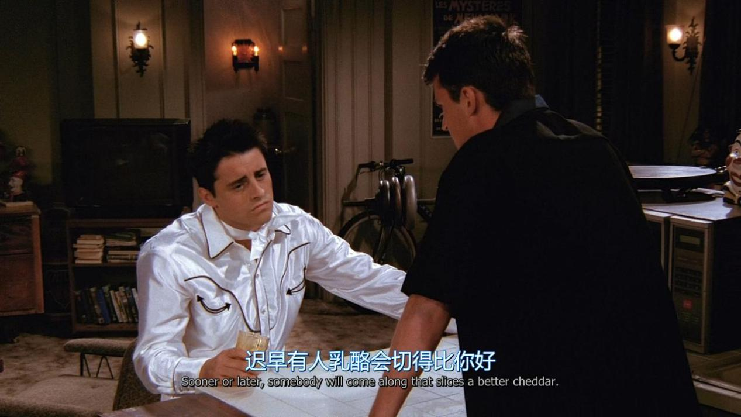

Sonner or late, sb will come along that slices a better cheddar

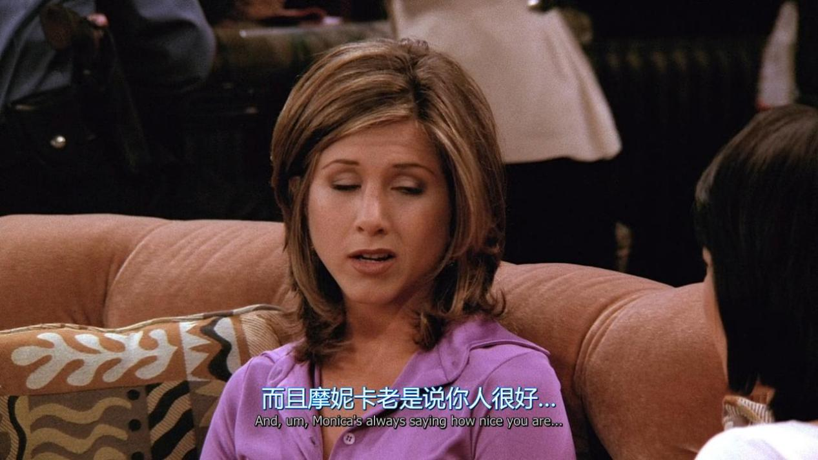

XX always saying how nice you are

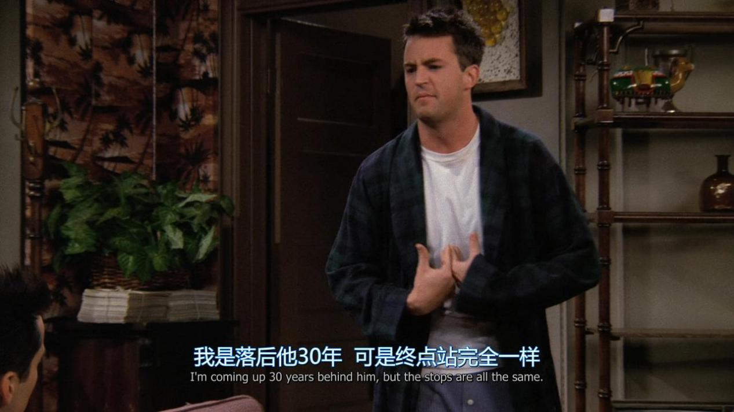

I am coming up 30 years behind him,but the stops are all the same

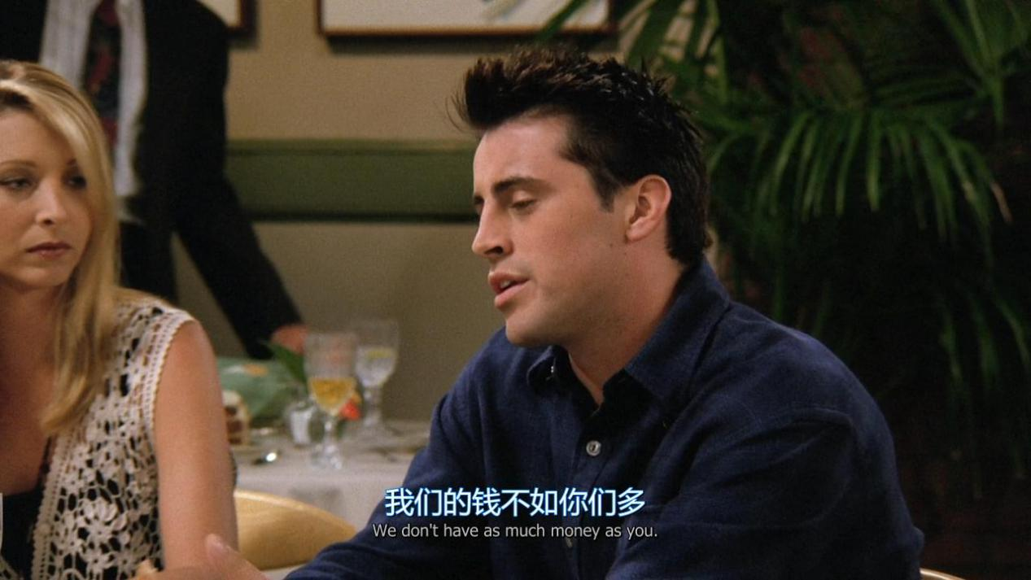

We don’t have as much money as you

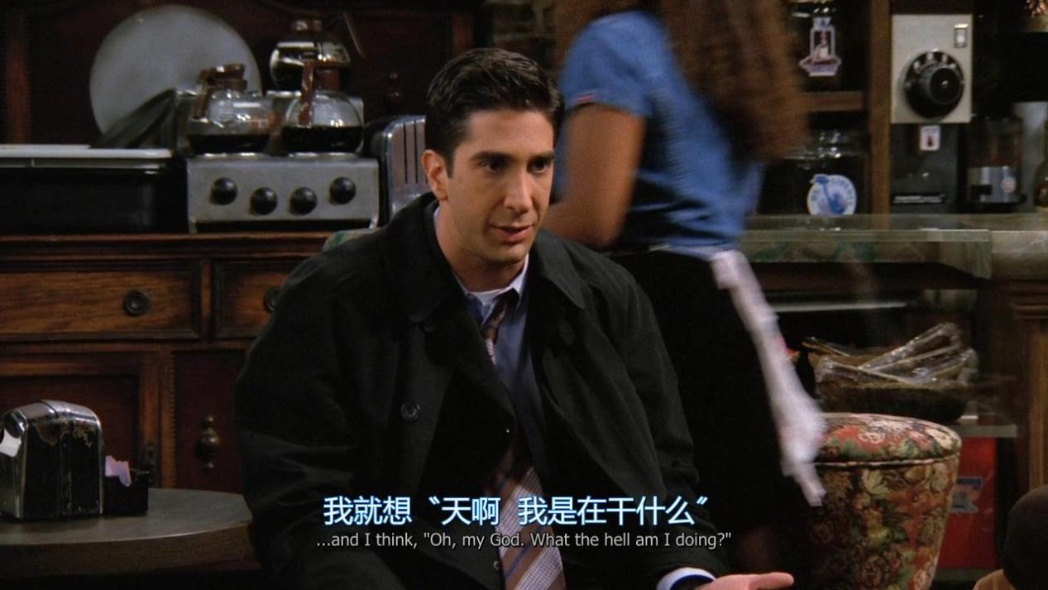

What the hell am i doing ?

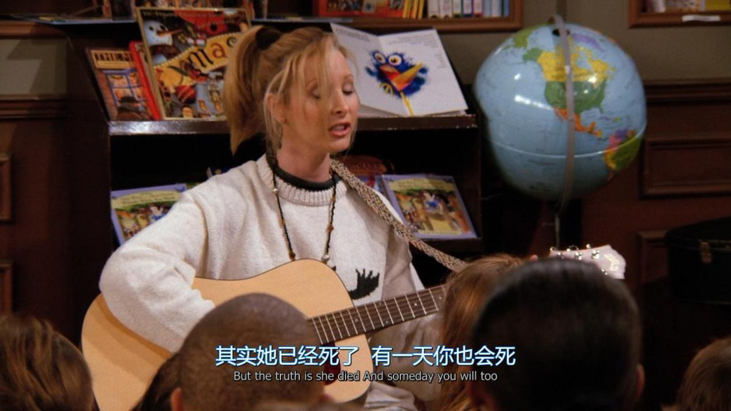

But the truth is she died and someday you will do

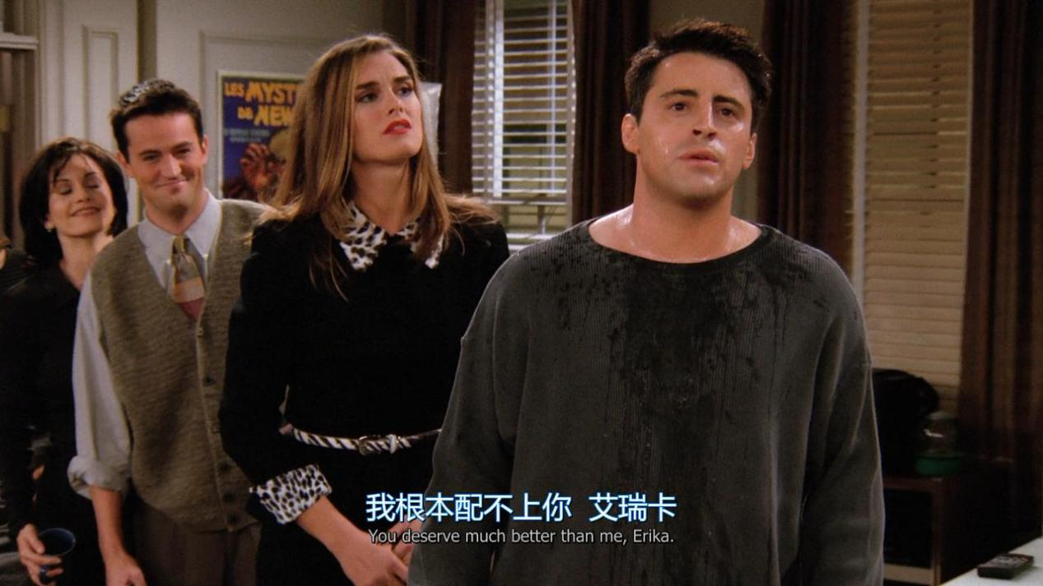

You deserve much better than me.

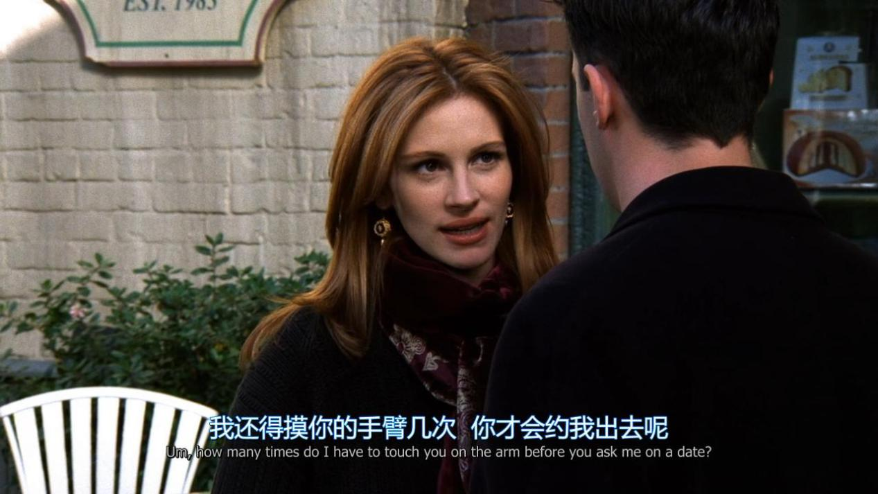

How many times do i have to touch you on the arm before you ask me out on a date?

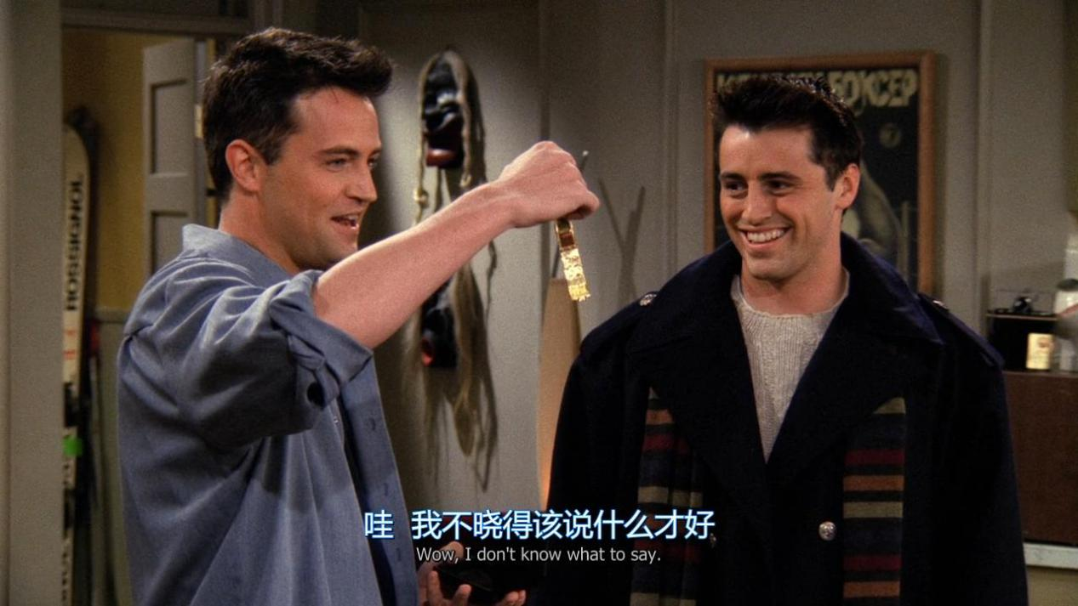

I don’t know what to say

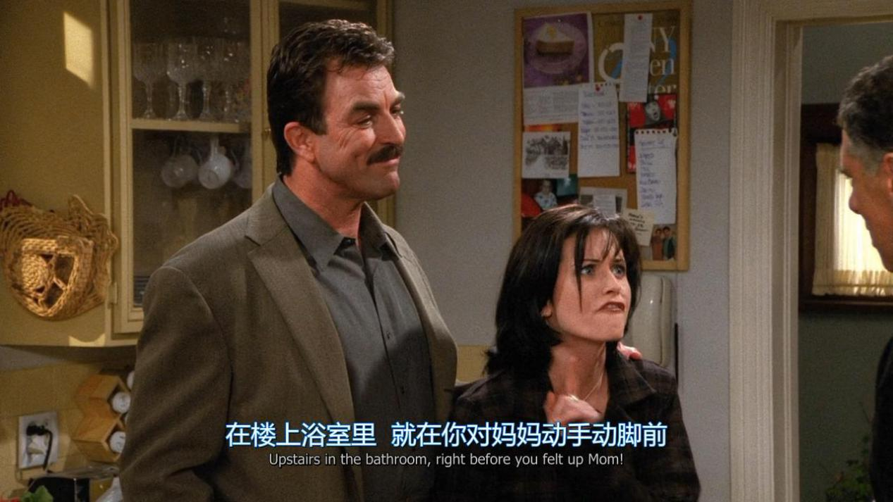

Upstairs in the bathroom, right before you felt up Mom.

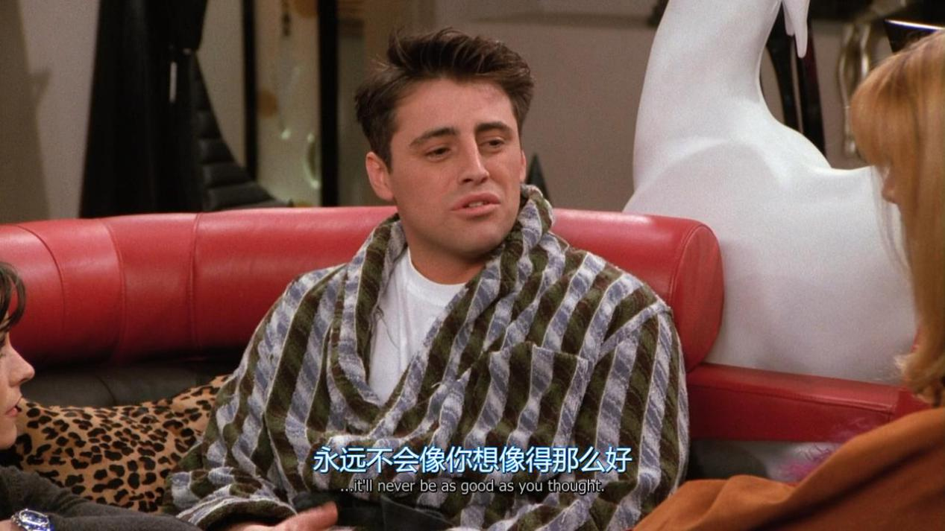

Never be as good as you thought

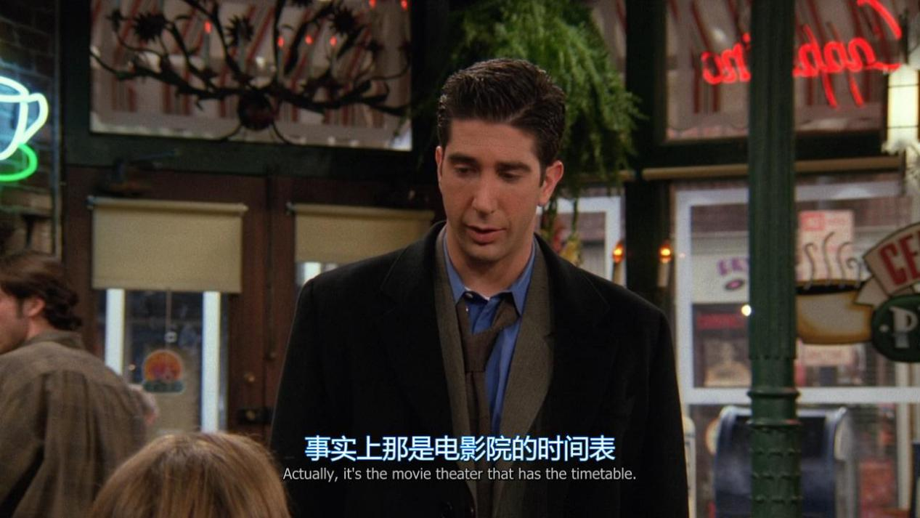

Actually ,it’s the movie theater that has the timetable

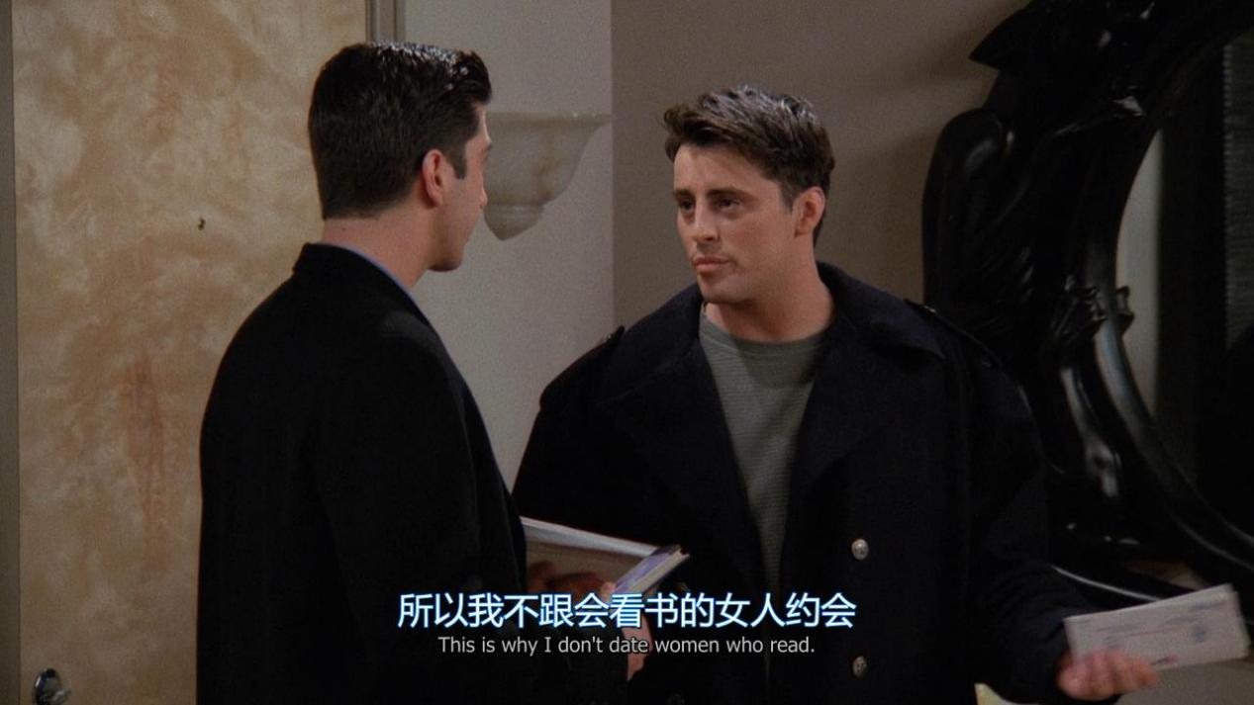

That’s why i don’t date woman who read

Put yourself into others’ shoes

In the very near future

Don’t ever let sb tell u u can’t do sth, not even me

An America where a father can tell his daughter:yes,u can be anything you want to be.Even a president of the United State.

I guess i got tired of waiting around somebody else to do it for me

If i was walking down the street and i saw some kids with a jet pack

fly over me,i would believe anything’s possible and what a wonderful world.I’d be inspired,doesn’t that make the world a better place

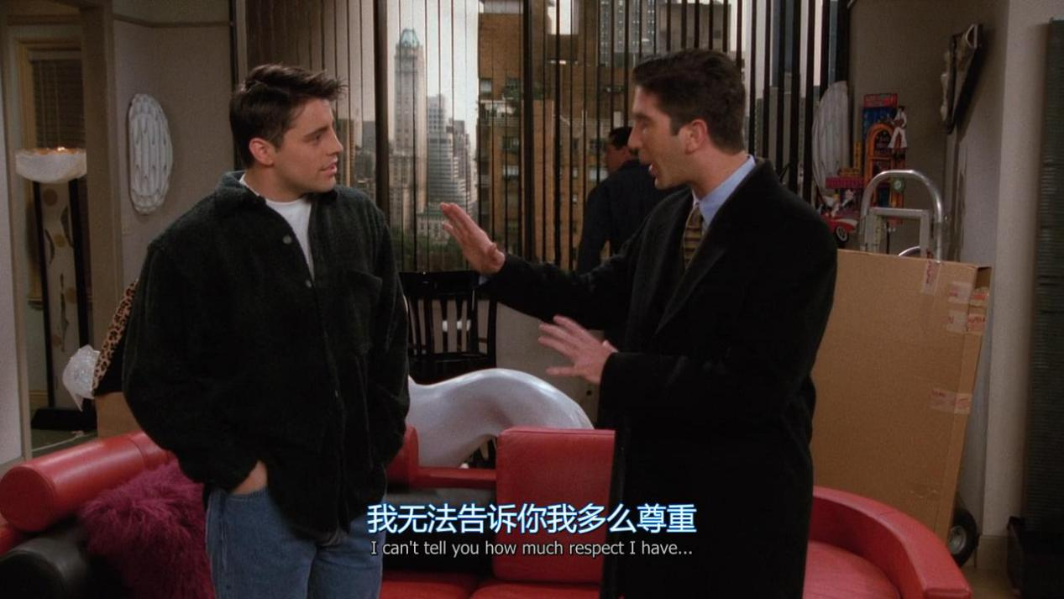

I can’t tell you how much respect i have

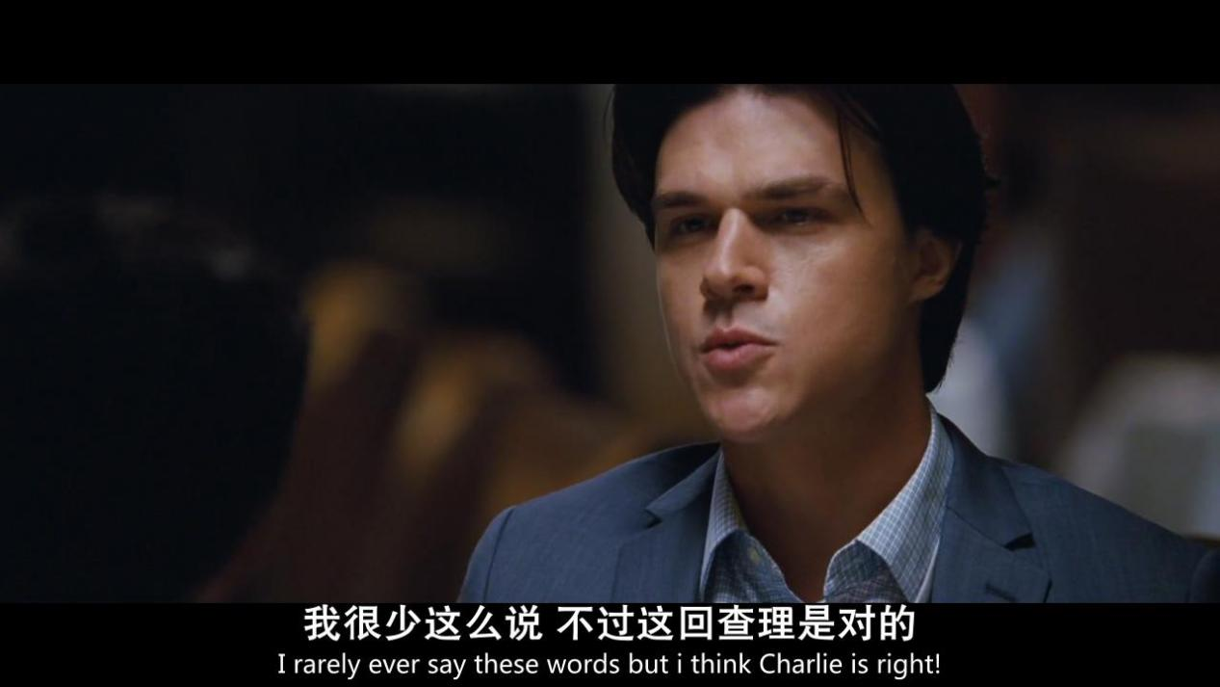

I rarely ever say these words but i think XX is right

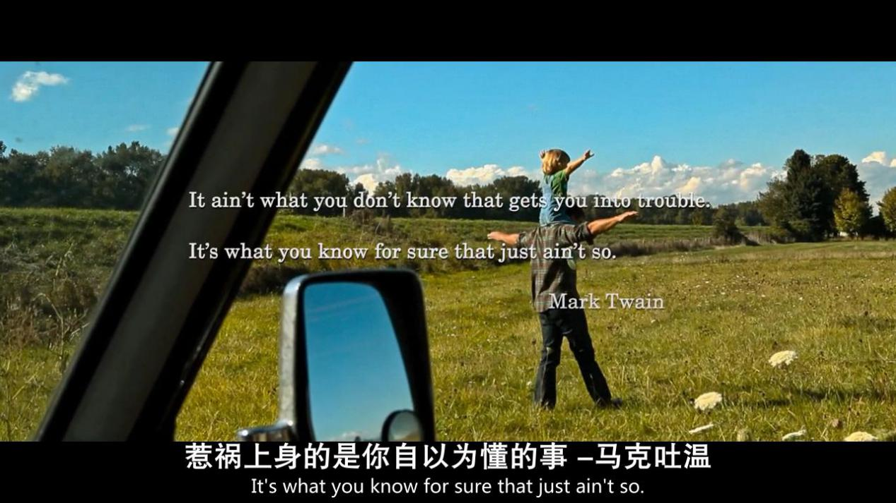

It ain’t what you don’t know that gets you into trouble,it’s what you

Know for sure that just ain’t so.

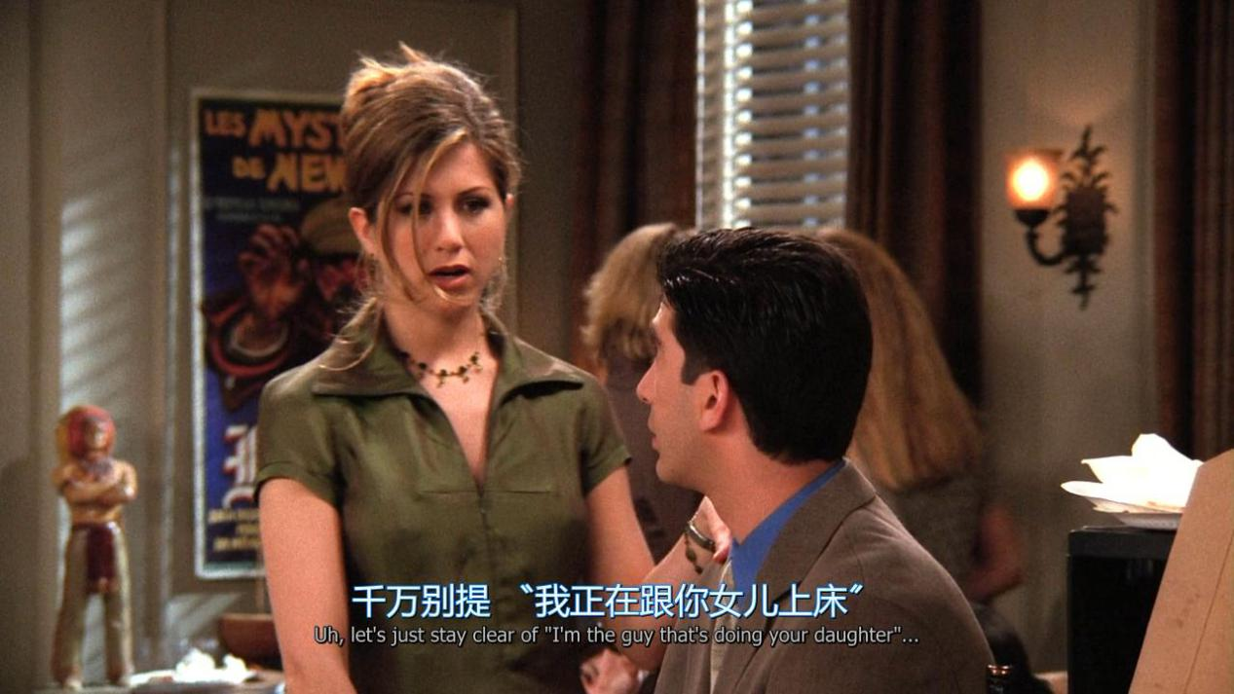

I’m the guy that’s doing your daughter

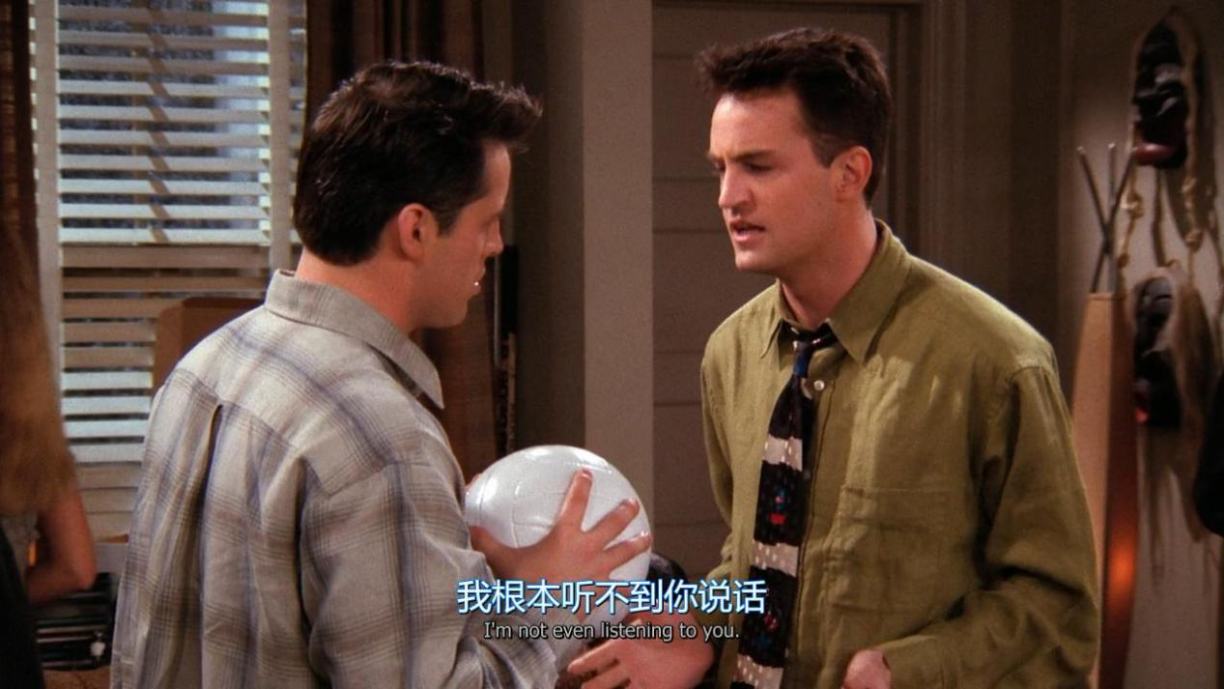

I’m not even listening to you

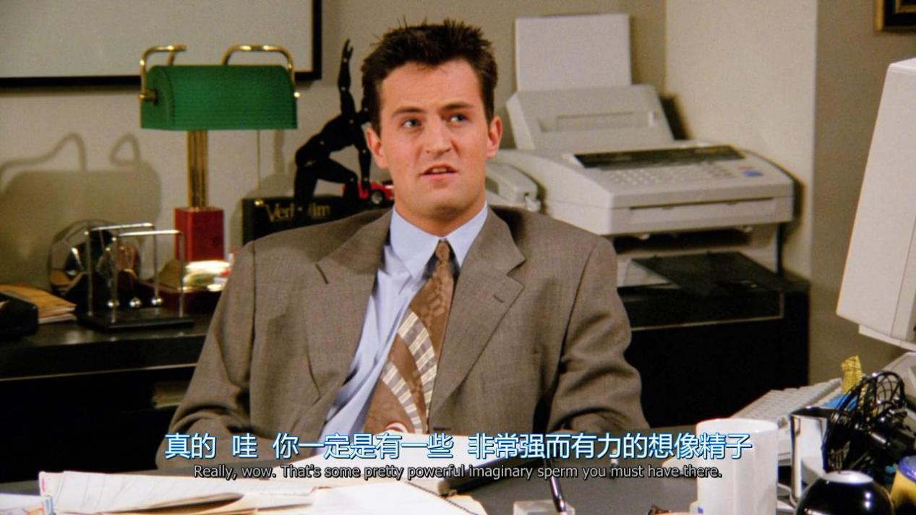

That’s some pretty powerful imaginary sperm you must have there